REGIONAL TRADE INTEGRATION UNDER TRANSFORMATION

Regional Trade Agreements Section
Trade Policies Review Division
WTO Secretariat

Preliminary Draft
prepared for the

seminar on
Regionalism and the WTO
WTO Secretariat, Geneva, 26 April 2002

Introductory Remarks
          - The 1990s was a prolific decade for regional trade initiatives and early data from the last two years suggest that this trend looks set to continue. The number of regional trade agreements (RTAs) being negotiated has increased exponentially and their scope as well as their geographical reach have both broadened and expanded. The resilience of this trend is likely to intensify further as the few remaining countries traditionally favouring multilateral-only trade liberalization have initiated - or are actively considering - negotiations of several RTAs. In this sense, the option of regional trade liberalization has become for virtually all countries (whether WTO Members or not) a very attractive tool for managing their trade policies alongside multilateral trade negotiations.
          - The objective of this paper is to picture the evolving landscape of RTAs and to provide a brief update on recent developments and directions. Four broad themes are explored: RTAs' kaleidoscope looks at main trends and characteristics of RTAs, both in force and under negotiation; the globalizing scope of RTAs presents current and prospective regional and cross-regional developments, together with estimates of RTAs' share of world trade; the spillover effects of RTAs examines RTAs' coverage, rules of origin and the implications of overlapping agreements; lastly, there is a brief description of RTAs within the WTO context.
          - Unless otherwise stated, the statistics offered in this paper take account of all bilateral, regional, and plurilateral trade agreements of a preferential nature, and include RTAs which have been notified to the GATT/WTO as well as those which have not (or not yet) been notified, without any distinction. Although the primary focus is on free-trade areas (FTAs) and customs unions (CUs) in the area of goods and economic integration agreements (EIAs) in the area of services, details on partial scope or non-reciprocal arrangements have been included, where possible and appropriate.

RTAs' Kaleidoscope

Main trends
          - Compared to previous decades, the proliferation of RTAs during the last ten years has taken place at an unprecedented rate. As of March 2002, 250 RTAs had been notified to the GATT/WTO, of which 168 are currently in force; of the 125 RTAs notified during the GATT years, only 51 remain today in force, reflecting in most cases the evolution over time of the agreements themselves, as they were superseded by more modern ones between the same signatories (usually going deeper in integration), or by their consolidation into wider groupings.
          - In the 1990s, the number of notified RTAs began to surge upwards. Uncertainty concerning the outcome of the Uruguay Round has been one of the reasons advanced for such a trend, another possible explanatory factor being the integration efforts within Europe after the collapse of the COMECON block.
          - After the conclusion of the Round and the establishment of the WTO the appeal of regional integration has, however, continued to grow. Since 1 January 1995, a further 125 new RTAs have been notified, with an average of 15 notifications every year to the WTO, compared with an annual average of less than three during the four and half decades of the GATT(see Chart 1). In part, the increase in notifications is a reflection of increased WTO membership and new notification obligations. But, this apart, it is obvious that the rate of growth of RTAs is continuing unabated.
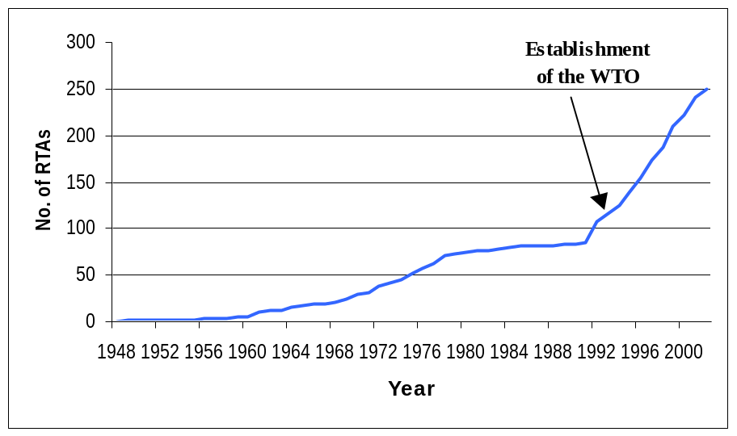Chart 1 - RTAs notified to the GATT/WTO (1948-2002), cumulative

          - Of the 141 notified RTAs which are currently in force, 124 are intended to be free trade areas and customs unions. If RTAs not (or not yet) notified are also taken into account, the total number of RTAs in force rises to 243, of which 197 have the format of either free-trade areas or customs unions. It is estimated that by 2007, a further 87 RTAs will be in force, if those currently being planned or under negotiation are concluded.

Main characteristics
          - Regional trade agreements differ considerably in scope, varying from the exchange of preferences on a limited range of products between two or more countries, to include various trade-related provisions going beyond traditional tariff reduction or elimination. For the most part (though not exclusively), partial scope agreements concern RTAs concluded among developing countries. RTAs among developed countries tend to be more far-reaching reflecting, among other developments, decreasing tariff levels in OECD countries for most non-agricultural goods. The new generation of RTAs, especially those involving developed countries, tend to go far beyond traditional tariff-cutting exercises and even beyond the realm of existing multilateral rules: trade agreements include more and more regional rules on investment, competition and standards; in a few cases, they also contain provisions on environment and labour. In these and other ways, many of the new RTAs are paralleling or anticipating the evolution of the GATT/WTO system.
          - Chart 2 shows a typology of RTAs in force as of March 2002. The most common category is the free trade agreement (FTA) which accounts for 72 per cent of all RTAs. Partial scope agreements and customs union agreements account for 19 and 9 per cent, respectively. Eighteen of the RTAs identified (17 FTAs and 1 customs union) contain commitments on trade in services in addition to tariff concessions on goods. The trend towards the conclusion of free trade agreements, which require a lesser degree of integration and are faster to conclude, has intensified in recent years. In an FTA each party maintains its own tariffs vis-à-vis third parties. Customs unions, which provide for the establishment of a common external tariff and harmonization of trade policy, often take years to negotiate and have (often) long implementation phases.
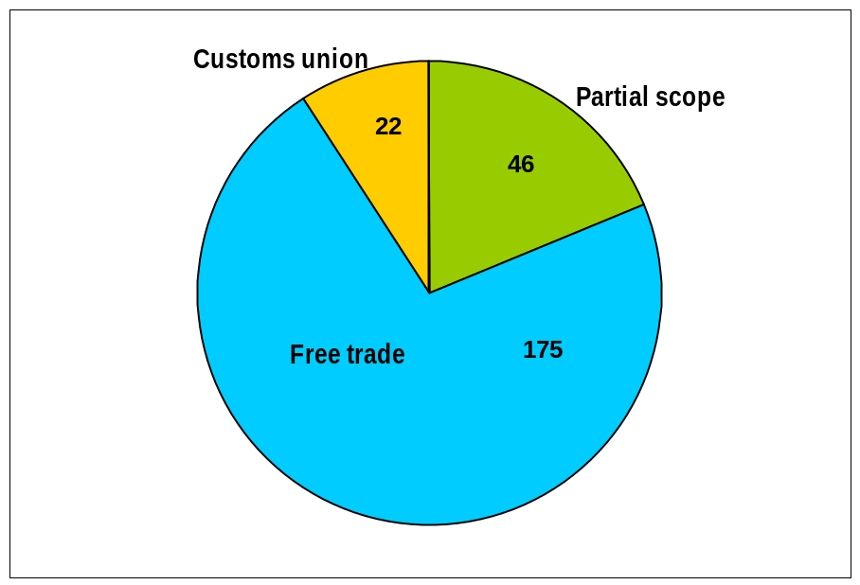Chart 2 - RTAs in force, as of March 2002,
by type of agreement

          - The configuration of RTAs is diverse and becoming increasingly more complex with overlapping RTAs and networks of RTAs spanning within and across continents at the regional and sub-regional levels. The simplest configuration is a bilateral agreement formed between two parties. These account for more than half of all RTAs in force and for almost 60 per cent of those under negotiation. More complex are plurilateral RTAs and those agreements in which one of the parties is an RTA itself; the latter account for 25 per cent of the RTAs currently in force. The most noteworthy development expected in the next five years is the emergence of a new category of agreement, namely RTAs where each party is a distinct RTA itself. At present, there are no agreements of this kind in force, but several are currently under negotiation and this tendency looks set to intensify in the near future. This is a new trend which is a reflection of the growing consolidation of established regional trading relationships.

Globalizing Scope of RTAs

Regional and cross-regional developments
          - The three first maps presented at the end of this paper illustrate the geographical development of RTAs.
          - Map 1 shows the degree of involvement of individual countries and customs territories in RTAs covering trade in goods which were in force in March 2002. Map 2, which builds on Map 1, provides an indication of the situation in 2007, if the RTAs currently under negotiation come into force. Each map gives an indication of the total number of agreements each country is involved in through the use of six different colours for six ranges of numbers. Only RTAs which are intended to be free-trade areas and customs unions in force have been taken into account. For the purpose of this map all RTAs have been treated equally, despite the fact that their scope, coverage and depth of liberalization may differ considerably.
          - As can be seen from Map 1, the greatest concentration of RTAs is in Europe, particularly in the EC and EFTA countries which have similar networks of RTAs. The central European countries, the Baltic states and Turkey are also engaged in a number of RTAs. This process has recently also extended to South-Eastern Europe, in particular the countries of the former Yugoslavia, which are negotiating bilateral RTAs among themselves within the framework of the Stability Pact initiative launched in 1999. Looking ahead to the situation in 2007 which is shown in Map 2, the enlargement of the EC to include 12 new countries (Bulgaria, Cyprus, the Czech Republic, Estonia, Hungary, Latvia, Lithuania, Malta, Poland, Romania, the Slovak Republic and Slovenia) will have two opposing effects. One the one hand, the number of RTAs in which the EC participates will decrease, as its bilaterals with the acceding countries will cease to exist. On the other hand, the acceding countries' participation in RTAs will increase as they will automatically become parties to the EC's existing network of RTAs. The network of RTAs of the EFTA countries and of Turkey and Israel will similarly be reduced as their bilateral networks of agreements with the acceding countries are replaced by a single RTA with the EC. Overall, we expect to see a concentration and consolidation of RTAs in Europe over the next five years, rather than a net expansion.
          - In the Western Hemisphere the process of regional integration has been intensifying rapidly in recent years with networks of bilateral and plurilateral RTAs being established both at the regional and sub-regional level. As can be seen from Map 2, this trend is part of a rather homogeneous process of integration across the continent as whole. Canada has recently concluded an RTA with Costa Rica, and is set to expand its preferential trade links further with the countries of Central and South America. Similar intentions have been voiced by the United States, which is currently negotiating an RTA with Chile. In Central and South America, Mexico and Chile are developing further their already dense network of bilateral RTAs, as well as looking further afield to cross-regional RTAs with Europe and countries in East Asia and Southeast Asia. At the plurilateral level, MERCOSUR (Argentina, Brazil, Paraguay and Uruguay) is engaged in regional trade negotiations with neighbouring countries as well as with the EC, while the North American Free Trade Agreement (NAFTA) between Canada, the United States and Mexico is entering its last stage of implementation. On a continental level, the goal of a Free-Trade Area of the Americas (FTAA), encompassing 34 countries, is in place with firm deadlines for the conclusion of the negotiations set to no later than January2005.
          - In North Africa and the Middle East, Algeria, Tunisia, Morocco, Egypt, Israel, Jordan, Lebanon, the Palestinian Authority, and Syria are strengthening their ties with the EC through the negotiation of second-generation bilateral RTAs based on reciprocal exchange of preferences as part of the "Euro-Mediterranean Partnership" which is aimed at establishing a free-trade area by 2010. Similar agreements have been concluded or are being negotiated between these countries and the EFTA States. At the same time, the countries of North Africa are participating in various other regional trade initiatives both in Africa and the Middle East, such as the recent effort launched by the Arab League to establish an Arab Free Trade Area by 2007. For their part, Gulf Cooperation Council (GCC) countries are working towards the establishment of a common external tariff by 2005, and are engaged in discussions with the EC on the negotiation of a possible RTA; a Declaration on Cooperation has also been signed with the EFTA States.
          - In Sub-Sahara Africa, the regional integration process is gaining depth, although progress is uneven and far from certain due to the complex web of overlapping RTAs membership. In western Africa, countries are working at the completion of the West African Economic and Monetary Union (WAEMU) and the Central African Economic and Monetary Community (CEMAC). In eastern and southern Africa, members of the Common Market for Eastern and Southern Africa (COMESA) are advancing in their objective of creating a free-trade area grouping 20 countries, and similarly, the parties to the South African Development Community (SADC) have been working towards their objective of establishing a free-trade area by 2004, despite difficulties mainly due to overlapping membership with other RTAs, in particular the long-standing South African Customs Union (SACU) agreement. In addition to its efforts towards Southern Africa economic integration, South Africa has been active at the cross-regional level, with the conclusion of an FTA with the EC, and by exploring the possibility of similar RTAs with a number of other countries.
          - Africa-wide integration initiatives remain in place with the African Economic Community (AEC), aiming towards the setting up of an African Economic and Monetary Union by 2028, and the establishment of the African Union, with the ultimate goal of completing the economic integration of Africa, has been recently announced. A further push in consolidating the existing RTAs may come from outside the African continent through the Economic Partnership Agreements (EPAs) between the EC and the ACP countries which are due to be negotiated between September 2002 and January 2008. One of the major objectives of this new strategy (replacing the non-reciprocal relationship under Cotonou) will be to foster regional integration among the partners countries by establishing EPAs with groupings already engaged in a regional integration process.
          - In Central Asia, the regional structures pertaining to the Soviet era have been replaced by RTAs among the countries of the former USSR, as well as with their neighbours. In addition to the CIS free trade agreement and a customs union agreement (between the Kyrgyz Republic, the Russian Federation, Belarus, Kazakhstan and Tajikistan), a large number of bilateral agreements have also been concluded. In 2001, Georgia alone notified to the WTO RTAs with Armenia, Azerbaijan, Kazakhstan, Turkmenistan, Ukraine, and the Russian Federation. As shown in Map 2, it is expected that by 2007 there will be some consolidation of the current myriad web of bilateral RTAs.
          - Asia Pacific, is a region currently undergoing significant changes with respect to its stance towards regional integration, with a number of countries shifting their long-standing policy of MFN- only trade liberalization to actively consider the regional option. Also, the "open regionalism" typically associated with the Asia Pacific Economic Cooperation (APEC) appears to be counteracted by a drive towards preferential trade initiatives. Japan, Singapore and the Republic of Korea have been negotiating, and conducting feasibility studies for the establishment of several RTAs both among countries in the region and cross-regionally. Similarly, New Zealand and Australia are exploring the possibility of several RTAs with regional partners and further afield, in particular with countries of the western hemisphere. Singapore and New Zealand already concluded a far-reaching RTA and discussions are being held for a Closer Economic Partnership (CEP) between New Zealand and Hong Kong, China; Japan and Singapore recently initialled their own bilateral agreement. A notable development in the region, has also been the agreement between the members of the Association of South East Asian Nations (ASEAN) and China to initiate RTA negotiations. Japan and the Republic of Korea are also exploring the possibility of similar negotiations with ASEAN.
          - If looked at from a global perspective, the regional developments mentioned above clearly point to the emergence of a trend towards cross-regional RTAs. Most of the major players at the regional level are increasingly looking beyond their regional borders for partners in selective (often bilateral) preferential trade agreements. The EC and EFTA are leading this trend, however, other regions, in particular countries in North and Latin America are following suit. Similar agreements are in the pipeline for a number of countries. As a corollary to the increased overlapping membership of RTA-families, the coexistence in a single country of different trade rules and provisions, such as preferential rules of origin, is a frequent feature. As discussed below this lack of uniformity can severely hamper trade flows by the sheer fact of the costs involved for traders in meeting multiple sets of trade rules.
          - Map 3 shows the extent to which countries and customs territories are involved in EIAs notified to the WTO which cover trade in services and are in force in 2002. Countries, to date, have not negotiated separate RTAs for their services trade, but rather include concessions on trade in services as part of RTAs covering trade in goods. As can be seen from Map 3, far fewer countries participate in EIAs covering trade in services than in RTAs covering trade in goods: for the moment participation is limited to Europe, the NAFTA parties, Chile, Australia, New Zealand and Singapore. Nonetheless, the number of countries participating in EIAs, and the number of EIAs, are expected to grow over the next few years as the trend towards more comprehensive RTAs is set to intensify.

RTAs' Share of World Trade
          - Map 4 provides a rough estimate of the percentage of imports of goods from RTA partners for each country. Only agreements which are intended to be free-trade areas or customs unions, or interim agreements leading to one or the other were taken into account. Preferential agreements which are only partial in scope or non-reciprocal were not included in the calculation. No distinction was made between RTAs notified to the WTO and those not (or not yet) notified The figures were based on trade data for 2000, using RTAs in force.
          - While Map 4 provides a rough indication of the extent to which each country's imports are subject to preferences, a number of caveats should be borne in mind. It is important to recall that only a part of intra-RTA trade flows involve preferential treatment – the essence of an RTA – since (i) many tariffs are MFN-bound at zero (among the Quad countries, for example, the share of imports entering under bound MFN zero rates ranges from about 25% for Japan to somewhat over 40% for the EU); (ii) most RTAs exclude certain sectors, for example, agriculture; (iii) in some instances importers forgo free-trade treatment because the MFN duty is less than the cost of complying with rules of origin and other requirements; and (iv) most RTAs include a transition period, generally up to ten years, for the phasing in of tariff reductions on their most sensitive products.
          - As can be seen from Map 4, there is quite a wide variation in the percentage of trade which derives from RTA partners. As might be expected, European countries which participate in the greatest number of RTAs, also derive a significant percentage of their imports from RTA partners: most are in the 60 to 80 per cent range. The countries in Asia Pacific have the lowest percentages, while the situation in Latin America and Africa is more varied. Indeed, Mexico, Namibia, Lesotho, Malawi and Uganda derive over 80 per cent of their imports from RTA partners. Even countries which participate in few RTAs may derive a high percentage of their imports from their RTA partners, if those partners are also their major trading partners. For instance, Canada, which participates in 5 RTAs, imports nearly 70 per cent of its total imports from RTA partners. In contrast, Chile, which participates in 7 RTAs imports roughly 34 per cent of its imports from RTA partners. Therefore it is not necessarily the number of RTAs in which a country participates that determines the extent of a country's imports from RTA partners, but, rather, who those partners are.
          - Map 2 showed a projection for 2007, when a number of RTAs which are currently under negotiation are scheduled to be in force. The addition of RTAs such as the FTAA, the potential expansion of ASEAN to include China, and the enlargement of the EC to include 12 new countries will have a significant impact on RTAs' share of world trade. Given that preferential trade represents by the far the greatest exception to the WTO's principle of non-discrimination, the ongoing increase in trade conducted under RTAs points to a continuing erosion of trade conducted under MFN rules.

The Development Dimension of RTAs
          - Most developing countries participate in RTAs. Of the 243 RTAs estimated to be currently in force, between 30-40 per cent are agreements concluded between developing countries. These vary in form, ranging from customs unions, free-trade areas, partial scope agreements and non-reciprocal RTAs. Traditionally, partial scope agreements in which parties exchange concessions on a limited range of products, have been more recurrent among developing countries than developed ones. Recent developments, however, may point to a change in this trend, with an increasing number of developing countries opting for agreements favouring wider trade integration. One of the reasons which may help explain this shift, is the parties' political commitment to an economic restructuring process linked to a broader scheme of regional integration.
          - The path to regionalism chosen also differs considerably from region to region. Regional experiences in Africa, for instance, are in stark contrast to those experienced in East and Southeast Asia and Latin America. Many of the regional initiatives pertaining to the African continent have as their objective the establishment of customs unions or common markets, grouping a large number of countries and over long transition periods, often 20-30 years. The countries of East and Southeast Asia instead, have, at least until now, set themselves much more limited objectives usually in the form of free trade areas. Latin American countries seem to have chosen a rather more mixed approach with several customs unions in formation and plurilateral regional initiatives, but backed-up by an extensive network of bilateral RTAs, a feature which is missing in Africa.
          - An additional category of RTAs are those concluded among developed and developing countries. Until very recently, the majority of these agreements were concluded under the legal cover of a waiver from WTO provisions due to their non-reciprocal preferential nature. Recent trends, however, suggest a change in approach with a shift towards the conclusion of reciprocal RTAs between developed and developing countries. This is the case for the new wave of post-Cotonou EC agreements with the African Caribbean and Pacific countries (ACPs); and the Euro-Mediterranean agreements concluded between the EC and the countries of North Africa which replace the earlier non-reciprocal RTAs which were signed in the 1970s between these countries.

Spillover Effects of RTAs

Depth of Integration through RTAs
          - As mentioned above, the spectrum of RTAs' scope, coverage, and depth of liberalization varies widely. The big bang approach where tariffs are eliminated on all products from the date of entry into force of the agreement occurs, though rarely. More common is a phased introduction of tariff concessions leading to the elimination or reduction of tariffs between the parties.
          - A recent study by the Secretariat showed that the growing network of RTAs has served to reduce and, in most cases, eliminate existing tariffs on industrial products either on the date of entry into force of the agreement, or subject to progressive elimination in the course of its transition period; thus, the goal of free trade in industrial products appears to be the accepted norm. The treatment of agricultural goods within RTAs is, however, more complex. A few RTAs have eliminated all duties on agricultural goods, but in general agricultural trade, even on a preferential basis, remains subject to exceptions. Average agricultural preferential tariffs remain high and concessions on agricultural products granted by RTA partners tend to be parsimonious in nature. Nor have RTAs, for the most part, served to remove existing tariff peaks in the trade of agricultural products. The widespread use of the positive list approach in the granting of concessions on agricultural products in the majority of RTAs serves to limit the scope of potential concessions. The failure to use the selective (and hence "less risky") environment of an RTA to confront long-standing distortions, particularly in the trade of agricultural products, may serve to cement domestic constituencies resistant to change and undermine the willingness to deal with such issues on a multilateral basis. This is truly a lost opportunity.

Rules of Origin Regimes
          - Preferential origin regulations are an essential element of all RTAs except fully implemented customs unions. Whenever parties grant each other preferential market access but have not (yet) harmonized their treatment for goods imported from third countries, determination of the origin of an imported good is needed to ascertain whether such a good is eligible for preferential treatment in the importing country. Origin rules may also be justified to prevent products from non-parties to an RTA gaining preferential access to the market through the party which maintains the lowest external import restriction (i.e. to avoid "trade deflection").
          - A recent study by the WTO Secretariat demonstrated that the diversity of RTAs (or "RTA-families") results in a lack of uniformity in preferential rules of origin regimes world-wide. As a corollary to the increased overlapping membership of RTAs or RTA-families, the coexistence of different origin rules in a single country is a frequent feature. The vast majority of RTAs presently in force, as well as those currently under negotiation, include origin requirements where product-specific rules of origin are often supplemented by other provisions which can either add to or diminish their flexibility.
          - Preferential origin regulations are usually more stringent than MFN rules of origin, and the more so for products for which the margin of preference between the MFN and the preferential tariff is larger which may alter substantially the level and effective structure of the preferences established and result in potential inefficiencies in the allocation of resources among the preference-receiving trading partners; it may also increase the possibility of trade (or investment) diversion.

Effects of Overlapping
          - The proliferation of RTAs is closely connected with the phenomenon of overlapping regional trade agreements, also known as the spaghetti bowl effect. Overlapping raises a number of issues: firstly, differing rules of origin create a maze of (sometimes conflicting) criteria for the granting of origin which raises the cost of administering such agreements; secondly, membership in a number of different RTAs for a given country can result in the duplication and maintenance of tariff schedules for each preferential partner with different phase-out periods; thirdly, the difficulty in sustaining membership in two or more overlapping plurilateral RTAs (which is the case for several countries in Africa and Central Asia) should lead to the consolidation of RTAs and rationalization among participants who may be forced to align themselves with one or other regional grouping; fourthly, the dedication of resources to the negotiation and maintenance of agreements at the regional level may divert attention from negotiations at the multilateral level.
          - The more RTAs a country participates in, the greater the potential for criss-crossing tariff concessions and rules of origin. In addition, the greater its participation in plurilateral RTAs (which have three or more members), or in RTAs in which one party is an RTA itself, the greater the potential for complexity, especially where each country maintains a distinct preferential regime with each partner. Harmonization in the granting of tariff concessions and in rules of origin can reduce significantly the administrative burden associated with membership in multiple RTAs covering trade in goods. This scenario becomes even more complex if a country is involved in multiple RTAs covering trade in services, given that the harmonization of regulations across a number of preferential agreements presents an even greater administrative challenge.
          - Map 5 shows the number of RTA partners that result from participation in RTAs. Only FTAs and customs unions have been taken into account; participation in partial scope and non-reciprocal RTAs was not included. As might be expected, European countries have the greatest number of RTA partners, while those in the western hemisphere, for the moment, have the least. Yet, even countries which participate in few RTAs might need to negotiate and administer a considerable number of preferential relationships, depending on the composition of the RTAs. This is particularly the case for most sub-Saharan African countries which participate in few RTAs, most of which are plurilateral.

RTAs and the WTO
          - Developments in recent years suggest that the trend towards the negotiation of RTAs by WTO Members, which took off in the 1990s, is enduring. Prospects for the near future signal a further broadening of the scope of RTAs, with the inclusion of trade policy mechanisms in addition to tariff preferences, and as shown by some of the most recent regional trade initiatives, the geographical reach of RTAs is also expanding. Against this background it is hard to deny that preferential trade liberalization and regional trade policy negotiations, are increasingly paralleling the efforts pursued within the MFN framework.
          - The regional option has become an attractive tool for virtually all WTO Members for managing their trade policies alongside multilateral trade negotiations, seemingly confirming some of those arguments advanced in favour of RTAs. Thus, for instance, such agreements are deemed to accelerate and deepen trade liberalization on a bilateral or plurilateral basis. There is also a general feeling that complex policy issues of commercial significance in economic relations (notably services, investment, intellectual property protection, cooperation on competition policy, technical standards and government procurement) can better be managed amongst a limited circle of "friends". These motivations act as an incentive to regulate on such issues through RTAs, even if it is generally recognized that RTAs are a second-best option to MFN trade liberalization.
          - The GATT founders, and now the WTO, acknowledged that well-structured regional initiatives can contribute to the development of the multilateral trading system. Thus, from the start, Members have been allowed to further the market access they have bound in the GATT/WTO by concluding RTAs, albeit subject to a certain number of criteria contained in GATT Article XXIV, for agreements in trade in goods, and in GATS Article V, for agreements in the area of trade in services. The criteria are fundamentally three: (a) transparency, (b) commitment to deep intra-region trade liberalization, and (c) neutrality vis-à-vis non-parties' trade. The task of verifying the compliance of the RTAs notified by Members with these provisions is entrusted to the Committee on Regional Trade Agreement (CRTA). This Body, however, has enjoyed no success so far in assessing the consistency of the more than 100 RTAs notified to the WTO, (see Chart 3) due to various political and legal difficulties, most of which were inherited from the GATT years. One problem derives from the possible links between any CRTA consistency judgement and the dispute settlement process. Also, there are long-standing controversies about the interpretation of the WTO provisions against which RTAs are assessed, and institutional problems arising from either the absence of WTO rules (e.g., on preferential rules of origin), or from troublesome discrepancies between existing WTO rules and those contained in some RTAs.
Chart 3 - Status vis-à-vis the examination process of
RTAs notified to the GATT/WTO under GATT Art. XXIV
and in force on 31 January 2002
Cumulative figures
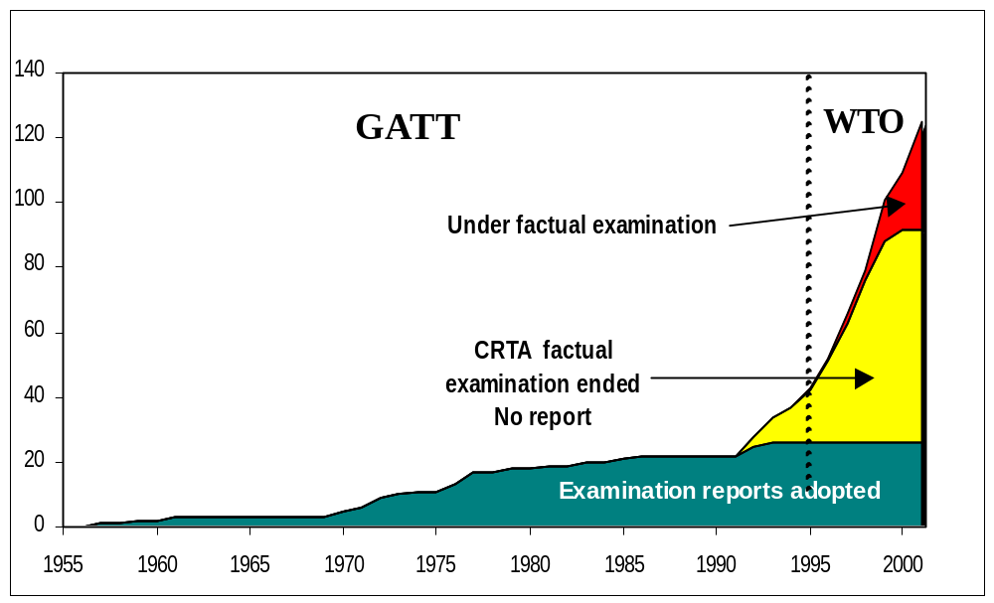

          - This deadlock can be explained by the "dispute-settlement awareness" mentioned above, in particular in the current situation of absence of an agreed relationship between reports on the examination and dispute settlement cases: Members are reluctant to provide information or agree to conclusions that could later be used or interpreted by a dispute settlement panel. It has been noted that a further negative consequence of this deadlock is that WTO litigation might replace multilateral examination of an RTA.
          - This situation has highlighted several areas requiring action. The conformity of regional trade initiatives with the basic message of deeper liberalization underlying the relevant WTO provisions is consistently put into question. The rising number of RTAs is also increasing the risk of incoherent trade policy regulations being implemented through these special regimes. And, lastly, detailed WTO rules and procedures applicable to RTAs are often considered inadequate to steer RTAs concluded by Members and, a fortiori, those announced for the coming years.
          - Against this background, WTO Members, meeting at the Fourth Ministerial Conference in Doha, while recognizing that RTAs can play an important role in promoting trade liberalization and in fostering economic development, also stressed the need for a harmonious relationship between the multilateral and regional processes. On this basis, Ministers agreed to launch negotiations aimed at clarifying and improving the disciplines and procedures under the existing WTO provisions applying to RTAs, by taking due account of the developmental aspects of these agreements.

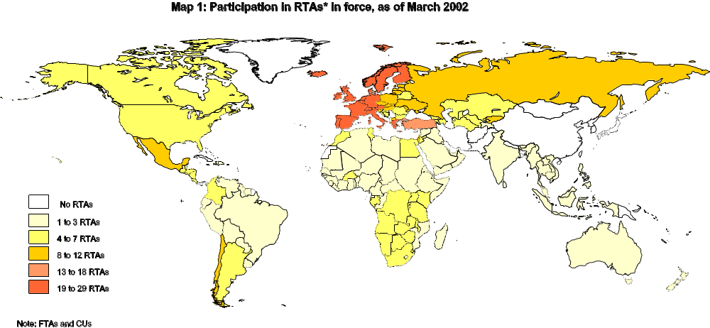
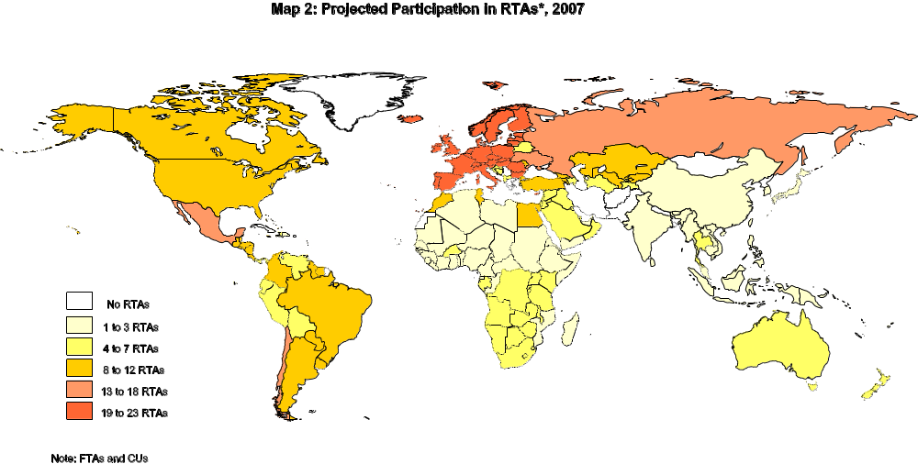
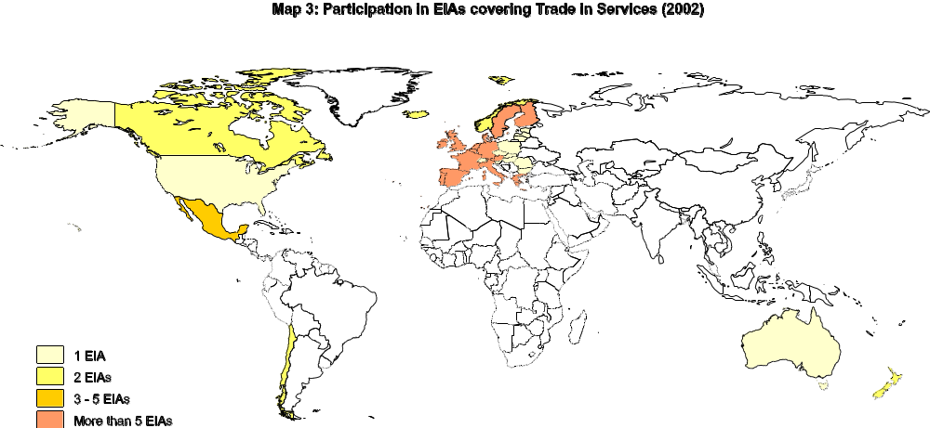

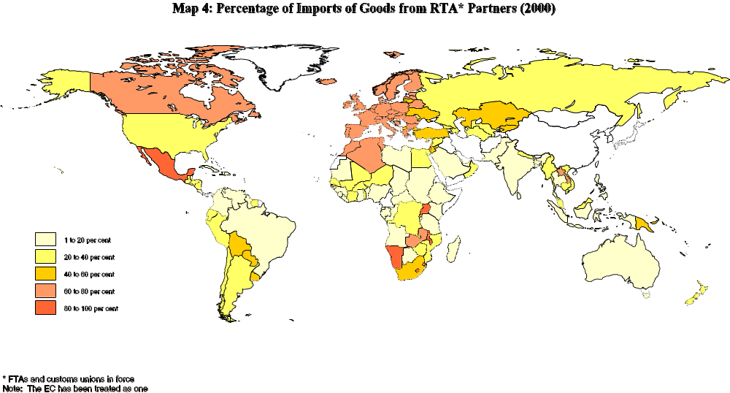
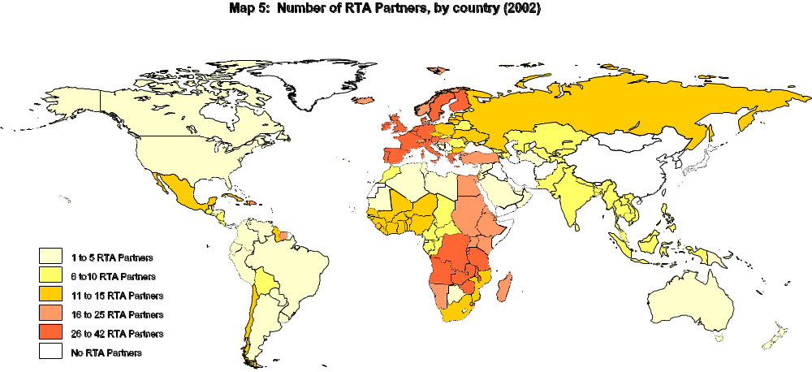

Included in this number are notifications made under GATT Article XXIV, GATS Article V, the Enabling Clause, as well as accessions to existing RTAs; it should be noted that the notification requirements contained in WTO provisions on RTAs require that RTAs on trade in goods and RTAs on trade in services be notified separately even if the agreement covers both areas; see WT/REG/W/44 for a complete list of RTAs notified to the GATT/WTO and in force.
Since the establishment of the WTO, Members are required to notify EIAs in services.
This number does not take into account accession to existing RTAs, nor does it count the 18 notified EIAs covering trade in services.
Not every RTA under negotiation will automatically increase the number of RTAs in force, given the fact that some will supersede or expand existing RTAs.
Information on notified and non-notified agreements has been gathered from notifications to the WTO, reports on the operation of agreements and standard formats on information of RTAs submitted to the Committee on Regional Trade Agreements (CRTA), WTO accession documents, Trade Policy Reports, and other public sources such as press clippings, web sites, and publications of other organizations.
RTAs are increasingly concluded among geographically non-contiguous countries. The term “regional” may soon become an incongruity to describe the plethora of cross-regional preferential agreements linking countries around the globe.
This high number of bilateral agreements partly results from regional integration "hub-and-spoke strategies" requiring each "spoke" to conclude a bilateral RTA with the hub. The concept has been pushed a step forward by the EC, which (as a "hub") is often linked to "spokes" which also conclude bilateral RTAs among themselves (e.g. the Euro-Mediterranean Partnership process).
Examples include EC-MERCOSUR, CARICOM-CACM, SACU-SADC, to mention some.
Partial scope and non-reciprocal RTAs have not been included.
3rd Summit FTAA (Canada, April 2001). Deadlines were also set for market access negotiations: recommendations on methods and modalities are to be completed by 1 April 2002 and tariff negotiations are to be initiated no later than 15 May 2002.
Gulf Cooperation Council members (Bahrain, Kuwait, Oman, Qatar, Saudi Arabia and United Arab Emirates) plus Jordan, Tunisia, Egypt, Sudan, Syria, Somalia, Iraq, Palestine, Lebanon, Libya, Morocco, Yemen.
Benin, Burkina Faso, Côte d'Ivoire, Guinea Bissau, Mali, Niger, Senegal, Togo
Cameroon, Central African Republic, Congo, Equatorial Guinea, Gabon, Chad
Angola, Burundi, Comoros, Democratic Republic of Congo, Djibouti, Egypt, Eritrea, Ethiopia, Kenya, Madagascar, Malawi, Mauritius, Namibia, Rwanda, Seychelles, Sudan, Swaziland, Uganda, Zambia and Zimbabwe.
Members of SACU are Botswana, Lesotho, Namibia (it became a de jure member on July 1990), Swaziland and South Africa.
SADC, COMESA, ECOWAS, CEEAC and the Arab Maghreb Union, have been designated as pillars of the AEC.
5th Organization of African Unity(OAU) Extraordinary Summit, March, 2001
Brunei Darussalam (1987), Cambodia (1999), Indonesia, Laos (1997), Malaysia, Myanmar (1997), The Philippines, Singapore, Thailand, Vietnam (1995)
One example is Mexico: being part of NAFTA, it has recently concluded an RTA with the EC.
The study did not identify the number of EIAs currently under negotiation as countries negotiating agreements do not often specify whether they will cover goods, services or both, nor did it identify non-notified EIAs currently in force.
. Densities are calculated for each country by subtracting imports from RTA partners from total imports.
Data sources used were PC Comtrade and IMF Direction of Trade Statistics (2001). Data for COMESA countries were taken from their website (1998 data).
An example of this is the FTA recently concluded between Chile and Mexico and notified to the WTO under the provisions of GATT Article XXIV.
For instance the case of Latin American countries under the proposed FTAA.
Waivers currently in force are: US - Caribbean Basin Economic Recovery Act (CBERA), between the United States and 21 Caribbean and Central American countries; CARIBCAN, between Canada and 18 Caribbean countries; the Fourth Lomé Convention between the EC and 77 African, Caribbean and Pacific (ACP) countries.
See paragraph 17 above.
Coverage, Liberalization and Transitional Provisions in RTAs, WT/REG/W/46
Bearing in mind that MFN tariffs on such products, especially as applied by industrialized countries, were already at low levels.
Contrary to the practice generally adopted vis-à-vis tariffs on industrial goods, where a negative list approach is the norm.
Not only are MFN duty rates applied by the countries participating in a given preferential arrangement not usually the same, but each of these countries may also participate in separate arrangements with third countries under different preferential conditions.
Rules of Origin Regimes in Regional Trade Agreements, WT/REG/W/45
Mention should be made here of the "pan-European" (PANEURO) system of rules of origin, applied to preferential relations between the EC, the EFTA States and the Central and East European countries, within a network of free-trade agreements. PANEURO provides for the application of a single set of rules of origin and of diagonal cumulation of origin. This system is also used by the participating countries as a basis ("PANEURO- model") for most of the other RTAs they have concluded worldwide.
In an extreme scenario, the elimination of trade-restrictive measures (such as tariffs and QRs) could be counteracted by rules of origin to such an extent that there would be a de facto nullification of the trade liberalization provided under an RTA. In such a case, the costs incurred for the final product to be granted originating status would not be compensated by the benefits derived from the use of the preference, either because the margin of preference was not significant, the market not big enough, or the product was exported to a number of countries with differing rules of origin. Origin rules would then have the same effect as a trade barrier protecting domestic production of final goods.
The increasing importance of rules of origin may eventually lead producers to consider them as a factor of production per se that would be analyzed in the same manner as the availability and cost of inputs, labour costs, infrastructure, etc. In that sense, rules of origin can influence investment decisions, both with respect to sourcing of various inputs and location of production and result in producers increasing both inputs and processing within a preferential area at the expense of third parties that would otherwise have a comparative advantage.
For example, the RTAs signed between the EFTA countries and the countries of central Europe require that each central European country negotiate preferences with each EFTA country (counting Switzerland and Liechtenstein as one) individually and vice-versa.
In addition, a broad duty-free product coverage in RTAs is the exception as opposed to the rule, as the domestic forces that resist trade liberalization at the multilateral level are just as likely to resist it at the regional level. Furthermore, inconsistencies in the rules and procedures adopted by RTAs may not only act as a barrier to trade, but could also greatly complicate future efforts to develop a consistent set of multilateral rules and procedures governing countries’ trade-related policies. The result could be "regulatory gridlock", distortion of regional markets and severe implementation problems, especially when overlapping grids of RTAs are becoming more frequent.
The 1979 Decision of the GATT Council on Differential and More Favourable Treatment (Enabling Clause) governs the conclusion of preferential arrangements among developing countries (trade in goods only).
? The CRTA was established in 1996, in particular (a) to oversee, under a single framework, all regional trade agreements, and (b) to consider the implications of such agreements and regional initiatives for the multilateral trading system and the relationship between them.
As of December 2001, the Committee had 17 RTAs under active consideration ("factual examination"), and 23 in the waiting list. "Factual examination" had been completed for 82 RTAs, whose draft examination reports were in various stages of consultation and finalization.
For clarity reasons, the chart is based only on a subset of all RTAs notified to the GATT/WTO: those RTAs notified under GATT Article XXIV and known to be still in force on 31 January 2002.

