World Trade  Organization | RESTRICTED
World Trade  Organization | WT/REG/W/41  11 October 2000
 | (00-4180)
Committee on Regional Trade Agreements

mapping of regional trade agreements

Note by the Secretariat

During the Thirteenth Session of the Committee on Regional Trade Agreements (CRTA) on 13 September 1997, the Chairman stated that "to serve as a tool for the Committee's discussion on systemic issues, the Secretariat will compile factual information on Regional Trade Agreements (RTAs). This will be an evolving exercise, with blocks of information being distributed to Members as soon as they are processed". During the Eighteenth Session of the CRTA on 7 July 1998, the Committee requested that the Secretariat provide details, where publicly available, of all RTAs as this would enable the Committee to assess the complete picture of regional integration initiatives, both in force and in progress. A note entitled "Mapping of Regional Trade Agreements", was circulated informally in November 1998, providing a historical review of RTA developments.

This document contains the results of continuing research by the Secretariat and complements the earlier informal note. The objectives are threefold: first, to provide a snapshot of the web of relationships of regional trade agreements, at the sub-regional, regional, cross-regional, and global levels, that were in force as of July 2000; second, to indicate, where possible, how this web is likely to change over the years up to 2005, taking into account the impact of trade agreements currently under discussion or negotiation; and third, to identify emerging trends in the development of regional trading initiatives. The emphasis is on the visual presentation of data, using maps and charts to the greatest extent possible. Data definitions, methodology and caveats on the scope of the exercise are described below.

_______________

I. DEFINITIONS AND METHODS

1. This study takes account of all regional trade agreements, known to the Secretariat, which take the form of free-trade areas (FTAs), customs unions (CUs), or agreements leading to the formation of one or the other, either in force as of 31 July 2000 or under discussion or negotiation at that time., Information on agreements has been gathered from notifications to the WTO, reports on the operation of agreements and standard formats on information of RTAs submitted to the CRTA, WTO accession documents, Trade Policy Reports, and other public sources., While the document attempts to give an accurate indication of the situation, the information cannot be assumed to be exhaustive.

2. In defining the scope and coverage of this study, the Secretariat has chosen to include the following types of agreement, either in force or in planning:

- free-trade areas, defined as agreements among two or more parties in which reciprocal preferences (whether or not reaching complete free trade) are exchanged to cover a large spectrum of the parties' trade in goods;

- customs unions, defined as regional trade agreements with a common external tariff in addition to the exchange of trade preferences;

- free trade areas and customs unions which are asymmetrical in nature, i.e. which allow one or more of the parties (typically the less developed or transition economies) a longer transition period to implement the tariff reductions foreseen therein.

3. Conversely, the following types of agreements are excluded from the scope of this study:

- non-reciprocal agreements, i.e. those in which only one or more (but not all) parties to an agreement offer to make concessions;

- agreements which are partial in scope and do not seek to become free trade areas or customs unions;

- trade, cooperation, and investment agreements, and any other agreements aiming at facilitating trade but falling short of providing for tariff preferences inherent in a customs union or free-trade area.

4. For the purposes of this study, a customs union or free-trade area is assumed to be "in force" once the agreement has been signed and ratified. It should, however, be noted that this does not necessarily mean that all provisions of the agreement have been fully implemented.

5. In this study, five different geographical groups have been identified:

- Euro-Mediterranean (subdivided into Western Europe, Central Europe and the three Baltic countries, North Africa and the Middle East);

- Sub-Saharan Africa;

- Eastern Europe and Central Asia (which includes the countries of the former Soviet Union except the three Baltic countries);

- Asia Pacific; and

- the Americas.

II. Overview of Regional Trade Agreements
6. Regional trade agreements differ considerably in scope. In their simplest form, they provide for the exchange of preferences on a limited range of products between two or more parties. At the other extreme, they may both liberalize "substantially all" trade and contain trade disciplines which stretch well beyond traditional tariff elimination to areas such as standards, services, intellectual property and competition. While some RTAs on goods are fully functioning and have resulted in high levels of integration, others have been less successful. This study does not attempt to quantify the degree to which parties to RTAs have implemented their trade provisions.

7. Free-trade areas are generally, except in Africa, much more prevalent than customs unions. They account for almost 90 per cent of all RTAs identified in this study. Few, if any, FTAs provide for the complete elimination of all tariffs and non-tariff measures between their parties. Most provide for the elimination and/or reduction of existing tariffs, with varying degrees of exclusions. Customs unions generally provide for the establishment of a common external tariff in a number of stages to be completed over time. In some cases, these stages are either not clearly defined or often extended. Only a few of the RTAs identified in this study which were established with the aim of becoming a customs union have so far achieved that goal.

8. Not only do RTAs differ considerably in scope, but their configurations are diverse. The simplest configuration is a bilateral agreement formed between two parties; a plurilateral agreement unites three or more. More complex are agreements in which one (or more) of the parties to an agreement is an RTA itself. This can occur either in the case of a customs union (e.g. the agreements signed between the EC and the Euro-Mediterranean countries) or a free-trade area (e.g. the similar web of agreements signed by the European Free Trade Association (EFTA)). At present, there are no agreements in force to which all parties are themselves distinct RTAs, but several of this type are currently under negotiation.

9. The total number of RTAs identified in this study is 240, of which 172, or roughly 70 per cent, were in force as of July 2000, as demonstrated in Chart 1. The remaining 68 RTAs are defined as being under negotiation, a grouping which includes RTAs which have been signed but were not yet in force in July 2000, as well as those under discussion or negotiation, but which are likely to become fully-fledged RTAs in the next five years.

10. However, these numbers should be regarded with caution. First, given that some of the RTAs under negotiation will replace existing agreements, not every RTA currently under negotiation will result in a net addition to the number in force. Second, during the next five years it is expected that both the EC and MERCOSUR will enlarge their memberships. The accession of a new member to a customs union changes the network of RTAs to which the acceding member is a party, as it is usually obliged to assume the custom union's network of RTAs, while, at the same time, its own existing bilateral network of agreements is superseded. Thus the enlargement of a customs union can have a pronounced effect on the network of RTAs in force for a given region. Third, over the next five years it is possible that new alliances, which currently do not exist or are not yet publicly known, will be forged and old ones dissolved.
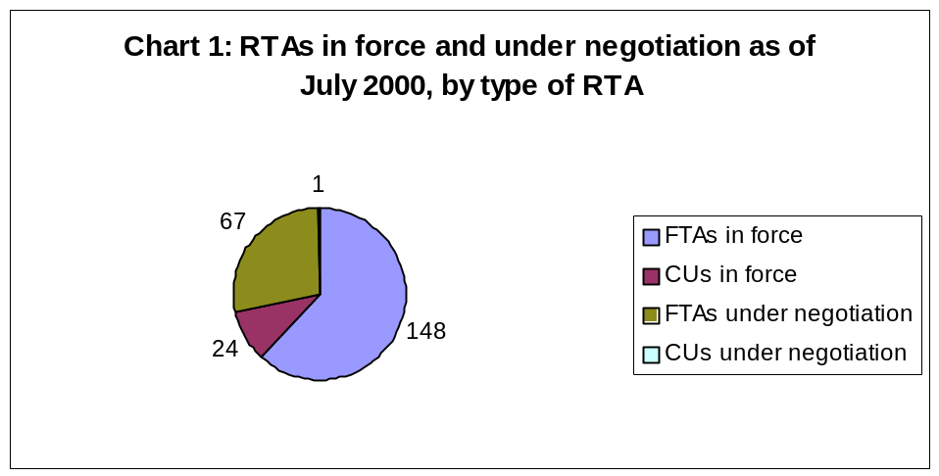

11. Chart 2 shows the geographical distribution of the RTAs identified in this study. Historically, the Euro-Mediterranean region, which accounts for over 50 per cent of all RTAs currently in force, has been the area of the greatest concentration of RTAs. Although this trend looks likely to continue in the short term, it is worth noting that almost as many RTAs are currently under negotiation in the Americas as in the Euro-Mediterranean region. These facts reflect both the relative maturity and the continuing dynamism of the process in the two regions. Another interesting recent development is the degree of activity in the Asia Pacific region, which has not in the past been a fertile breeding ground for RTAs. A number of initiatives in Eastern Europe and Central Asia are also underway; this is an area which might see some consolidation of existing RTAs in the next few years. The cross-regional group, which refers to RTAs which contain one (or more) signatories from two (or more) of the five geographic groups identified earlier in the paper, is expected to increase considerably with 15 RTAs currently in force and a further 14 under negotiation. Sub-Saharan Africa is the only region with no new RTAs currently under negotiation at the sub-regional level. However, one African regional group is currently negotiating a cross-regional RTA.

12. Again, the previous note of caution applies, i.e. not every RTA under negotiation will automatically increase the number of RTAs in force, given the fact that some will supersede or expand existing RTAs.
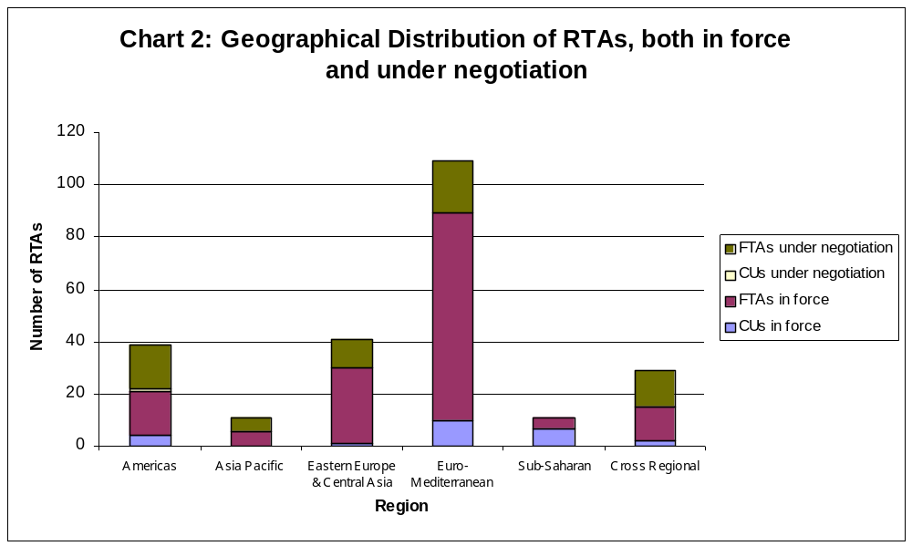

13. As mentioned earlier, the composition of RTAs varies, ranging from a simple bilateral RTA composed of two parties, to an RTA in which all parties are themselves distinct RTAs. Chart 3 shows a breakdown of the composition of parties to RTAs, of agreements which are in force and under negotiation. RTAs which are composed of two parties account for 98, or almost 60 per cent, of the 172 RTAs in force, and for half of all RTAs under negotiation. Plurilateral RTAs account for 16 per cent of all RTAs currently in force, but make up less than ten per cent of RTAs under negotiation. The percentage of RTAs where at least one party is an RTA itself is about 30 per cent of both the RTAs under negotiation and those in force. The most noteworthy development expected in the next five years is the emergence of a new category, namely RTAs where each party is a distinct RTA itself. These account for 9 of the 68 RTAs under negotiation and are composed of both regional and cross-regional initiatives. This is a new trend which is a reflection of the growing consolidation of established regional trading arrangements.

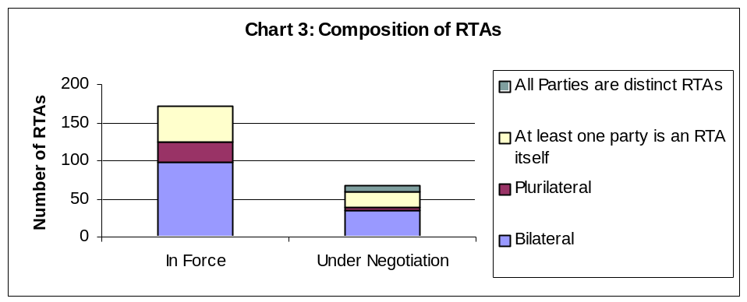

Iii. maps
14. This section contains a number of maps of two distinct types. The first (Maps 1-14) show the networks of RTAs in force at July 2000 and the changes expected to take place by 2005 at the regional, sub-regional and cross-regional levels. The second group (Maps 15-16) are density maps which show individual countries' participation in RTAs, both in force and under negotiation. A detailed description accompanies each group of maps. The arrows on the maps indicate the existence of bilateral agreements between two countries. Plurilateral agreements are shown in colour, or in the case of overlapping plurilateral agreements, by a symbol.

MAPS 1 - 2 Network of RTAs in force and under negotiation by the EC and EFTA and third countries in the Euro-Mediterranean region (2000/2005)

15. Map 1 shows the network of RTAs in force in July 2000 between the EC, EFTA, and other countries in the Euro-Mediterranean region., The EC has bilateral RTAs with each of the four EFTA countries and with the Faroe Islands. Although the webs of agreements between the EC and EFTA with third countries are closely linked, there are exceptions. As of July 2000, only the EC (not EFTA) had RTAs with Tunisia, Jordan, Cyprus, San Marino, Andorra and Malta.

16. Map 2 shows the network of RTAs expected to be in force by 2005 between the EC and EFTA with other countries in the Euro-Mediterranean region., By 2005, it is expected that EFTA will have concluded RTAs with Malta, Tunisia, Jordan, Lebanon, Egypt, Albania and the Former Yugoslav Republic of Macedonia (F.Y.R.O.M). Meanwhile the EC is expected to extend its network to include Algeria, Lebanon, Egypt and Syria. RTAs between the EC and EFTA respectively and the six member countries of the Gulf Cooperation Council should be in force by 2005. The enlargement of the EC to include Cyprus, the Czech Republic, Estonia, Hungary, Poland and Slovenia, also scheduled for 2005, will have a considerable impact on the existing web of agreements in this region. The six new EC members will automatically become parties to the EC's existing network of agreements, superseding the six acceding countries' bilateral RTAs. In the medium term, a Euro-Mediterranean free-trade area may be in place by 2010.

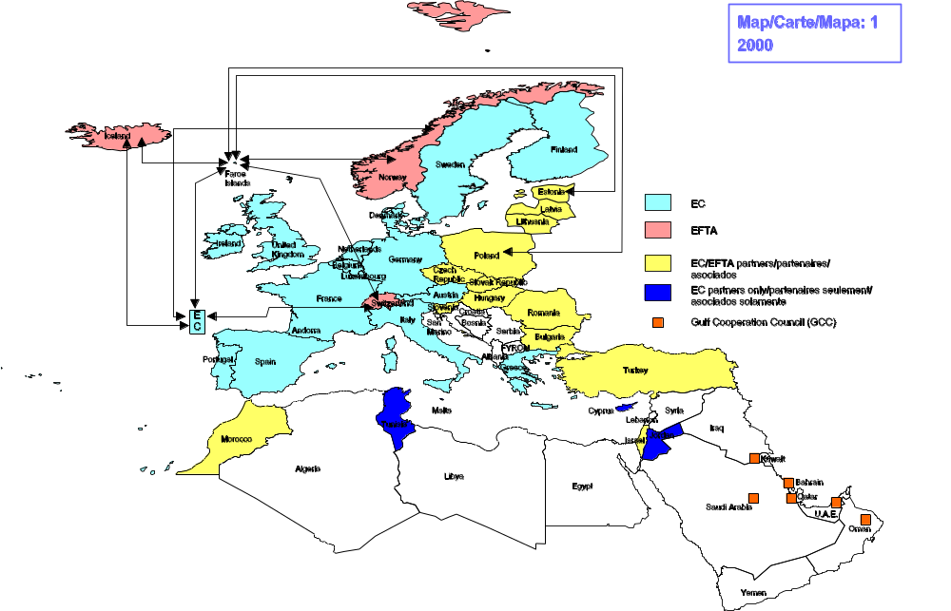
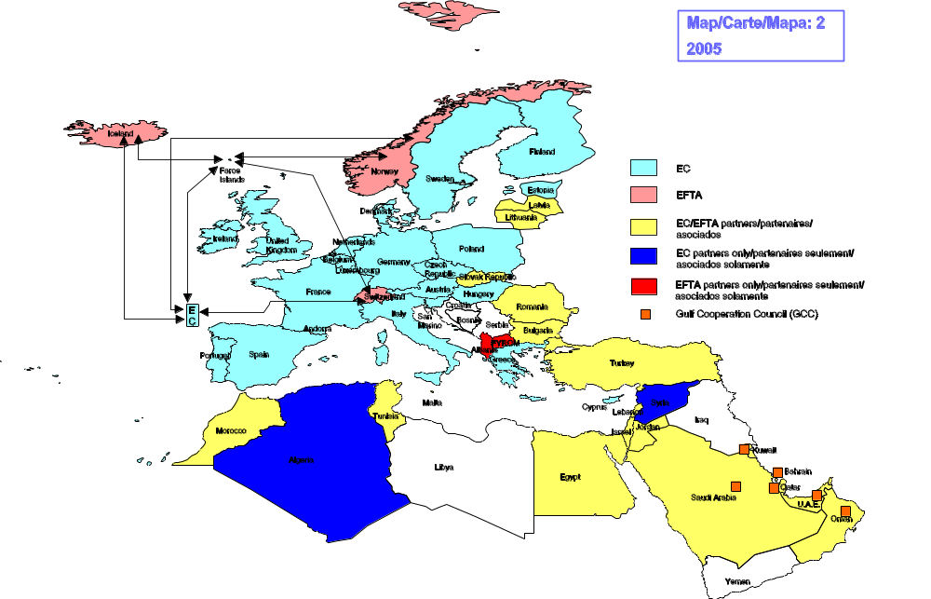
MAPS 3 - 4 Network of RTAs in force and under negotiation in Central Europe, the three
Baltic countries and the Middle East (2000/2005)

17. Map 3 shows the network of RTAs in force in July 2000 in Central Europe, the three Baltic countries and certain Middle Eastern countries. The two plurilateral RTAs in this sub-region are the Central European Free Trade Agreement (CEFTA) with seven members and the Baltic Free Trade Area (BAFTA) with three members. While there is a large number of bilateral agreements in force between the CEFTA member countries and the Baltic states, Turkey and Israel, this network of RTAs is not symmetrical. Two of the CEFTA members, the Czech and Slovak Republics, are linked by a customs union. Slovenia and Bulgaria have RTAs with F.Y.R.O.M. and Slovenia has an RTA with Croatia. As regards cross-regional agreements, Romania has an RTA with Moldova and the three Baltic countries have bilateral RTAs with Ukraine.

18. Map 4 shows the network of RTAs expected to be in force by 2005 in Central Europe, the three Baltic countries and certain Middle Eastern countries. The enlargement of EC-15 to EC-21, scheduled for 2005, will simplify and consolidate the web of RTAs in force in this sub-region, leaving CEFTA with three of its current seven members and the BAFTA with two of its current three. The number of bilateral RTAs to which Turkey and Israel are party will decrease, given that their bilateral RTAs with the EC's six acceding countries will be superseded by the EC's own RTAs. The separate customs union between the Czech and Slovak republics will presumably cease to exist. The EC's six acceding countries' new network of RTAs can be seen in Map 2.
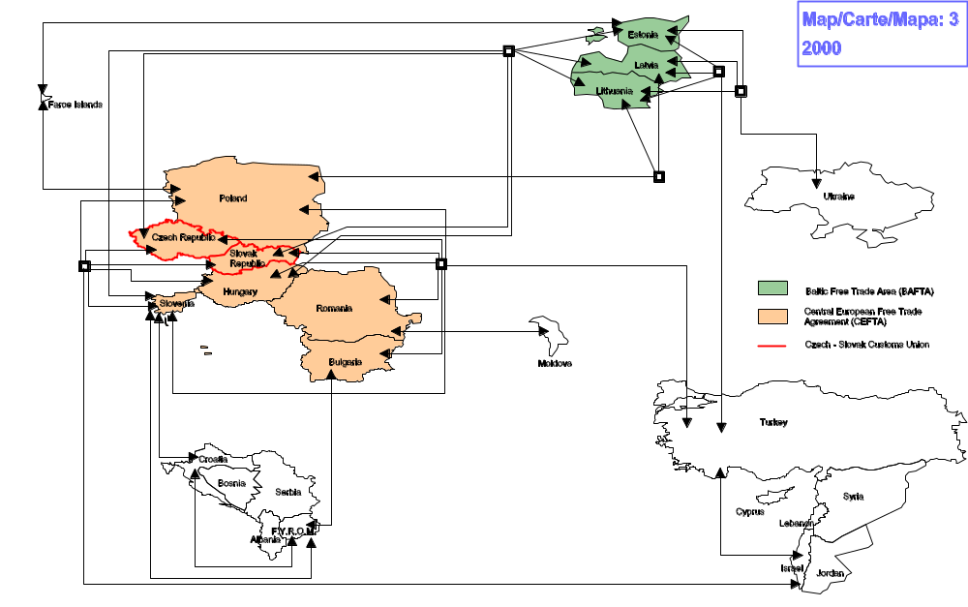
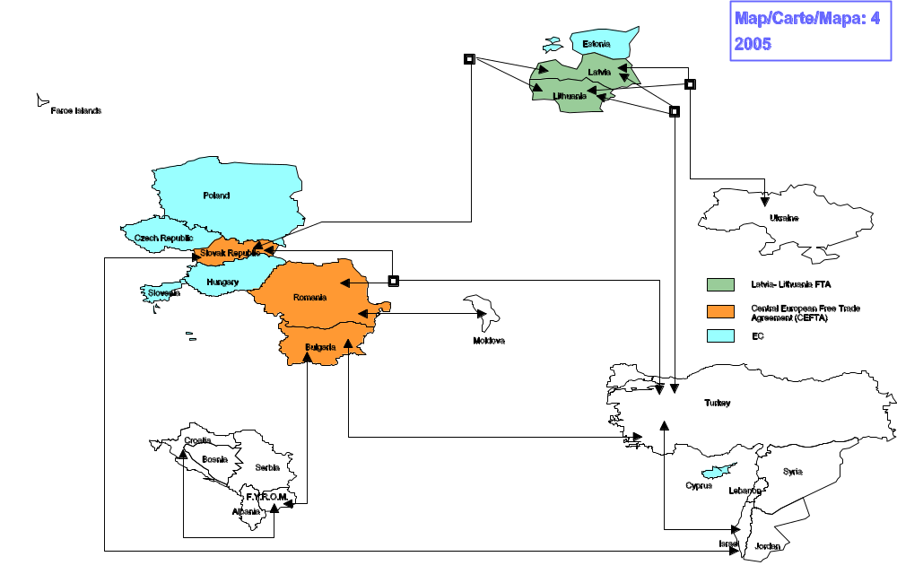
MAPS 5 - 6 Network of RTAs in force and under negotiation in North Africa and the Middle
East (2000/2005)

19. Map 5 shows the network of RTAs in force in North Africa and the Middle East., There are three plurilateral RTAs in this sub-region: the Arab Maghreb Union (AMU) with five members; the Gulf Cooperation Council (GCC) with six members and the Arab Free Trade Area (AFTA) which unites a total of 18 countries, including all members of the GCC, three of the five members of the AMU, and eight other countries.

20. Map 6 shows the network of RTAs expected to be in force by 2005 in North Africa and the Middle East. By 2005, Turkey, Morocco and Egypt are expected to extend their networks of bilateral RTAs, while the majority of countries in this sub-region should become part of the Euro-Mediterranean Free-trade area, scheduled for 2010.
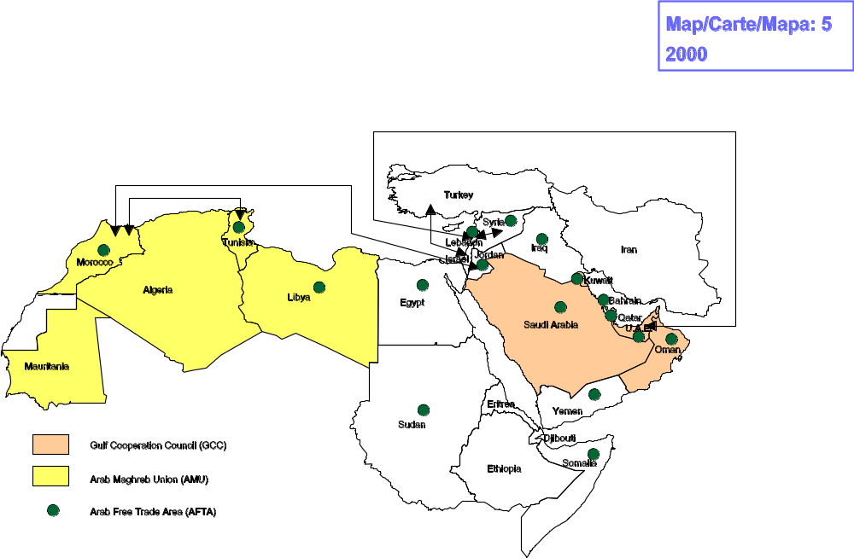
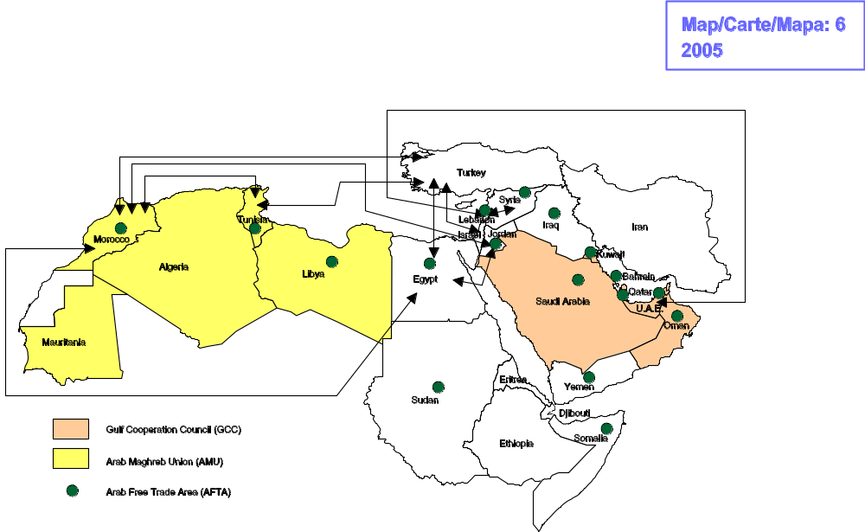
MAP 7 Network of RTAs in force and under negotiation in Africa (2000/2005)

21. Map 7 shows the network of RTAs for the whole of Africa which is valid for both 2000 and 2005, given that all RTAs expected to be in force by 2005 appear to be already in existence. One sub-regional group is actively negotiating a cross-regional RTA, as shown in Map 14. A distinguishing feature in Africa is the number of plurilateral RTAs (currently thirteen), many of them with overlapping membership and potentially conflicting goals.

22. In North Africa, there are two plurilateral RTAs: the Arab Maghreb Union has five members, while the cross-regional Arab Free Trade Area includes all North African countries except Algeria. Egypt is the only North African country which is a member of the Common Market for Eastern and Southern Africa (COMESA). In West Africa, there are three plurilateral RTAs: the Mano River Union (MRU) with three members; the West African Economic and Monetary Union (WAEMU) with eight members; and ECOWAS, which with a total of 16 members, unites the MRU and the WAEMU with Cape Verde, Gambia, Ghana, Mauritania and Nigeria. In Central Africa, there are two plurilateral groups: the Central African Economic and Monetary Union (CEMAC) with six members and the wider-reaching Economic Community of Central African States (ECCAS) which unites all six members of CEMAC with five other countries in the region. In Southern Africa, the five members of the Southern African Customs Union (SACU) are also party to the 14-member Southern African Development Community (SADC). In East Africa, the East African Cooperation (EAC) has three members, while the Cross Border Initiative (CBI) which stretches across eastern and southern Africa has fourteen. COMESA has a total of 20 members from North, East and Southern Africa. The only continental-wide group is the African Economic Community (AEC) which currently includes all countries in Africa except Morocco.

23. While membership in some plurilateral RTAs reflects linguistic similarities (e.g. WAEMU) or geographic clusters, e.g. SACU and SADC, others straddle these divides, e.g. ECOWAS and COMESA. Most African countries are party to two plurilateral RTAs, with a number party to three. Namibia and Swaziland are party to four. It is likely that some consolidation of Sub-Saharan RTAs will occur, either in terms of reduced or modified membership in RTAs or of mergers or obsolescence of certain RTAs. In the longer term, the African Economic Community has as its goal the creation of an African Common Market by 2020.

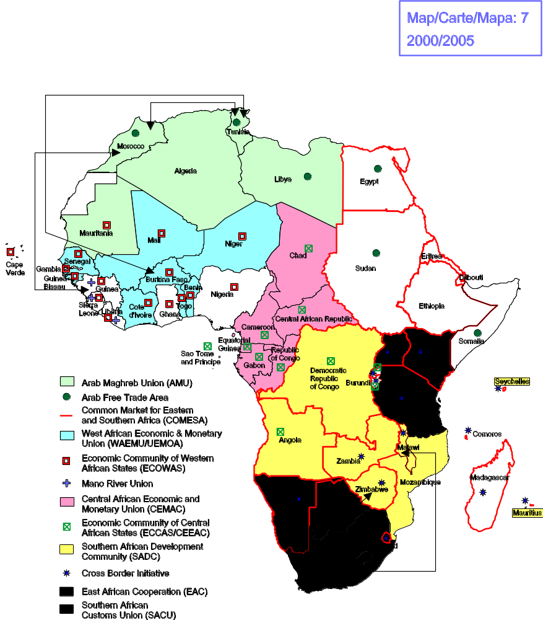
MAP 8 Network of RTAs in force in Eastern Europe and Central Asia (2000)

24. Map 8 shows the network of RTAs in force in Eastern Europe and Central Asia as of July 2000. A number of bilateral RTAs are in force, as well as a free trade agreement which unites all of the 12 countries in this region except Turkmenistan. The Russian Federation, Kazakhstan, Kyrgyzstan, Tajikistan and Belarus are members of a customs union. There are a number of bilateral RTAs under negotiation which should be in force by 2005 but the Secretariat has little information on these.
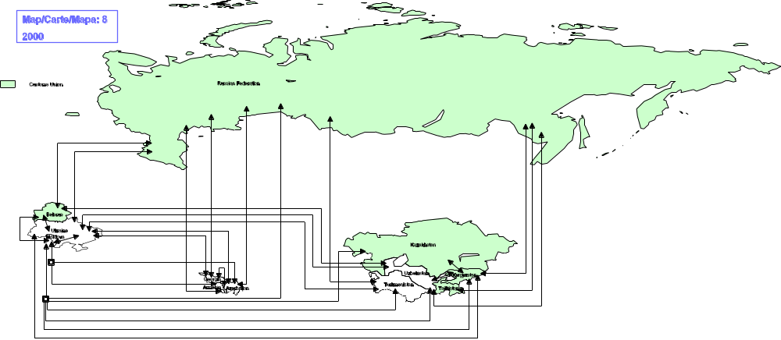
MAPS 9 - 10 Network of RTAs in force and under negotiation in Asia Pacific (2000/2005)

25. Map 9 shows the network of RTAs in force in Asia Pacific, the region with the smallest number of RTAs currently in force. The three main agreements are: ASEAN (Association of South East Asian Nations) Free Trade Area (AFTA) with 10 members; SAARC (South Asian Association for Regional Cooperation) Preferential Trading Arrangement (SAPTA) with 7 members; and the Closer Economic Relations Agreement (CER) with two members. While covering a significant number of economies, the three main RTAs do not include some of the major trading countries of the region such as China; Japan; Hong Kong, China; or Korea.

26. Map 10 shows the network of RTAs expected to be in force in Asia Pacific by 2005. By this time, there is likely to be an increase in the number of new RTAs in the region as well as some consolidation among the existing ones. Negotiations are underway for a free trade agreement between two of the main RTAs: ASEAN and CER. Moreover, members of the South Pacific Forum, which includes 14 Pacific islands as well as Australia and New Zealand, are considering going beyond their existing regional initiatives to conclude a Pacific Regional Trade Agreement (PARTA). At the same time, Japan, Korea, and Singapore are considering signing new bilateral trade agreements, not only with partners from the region but also from the Americas.

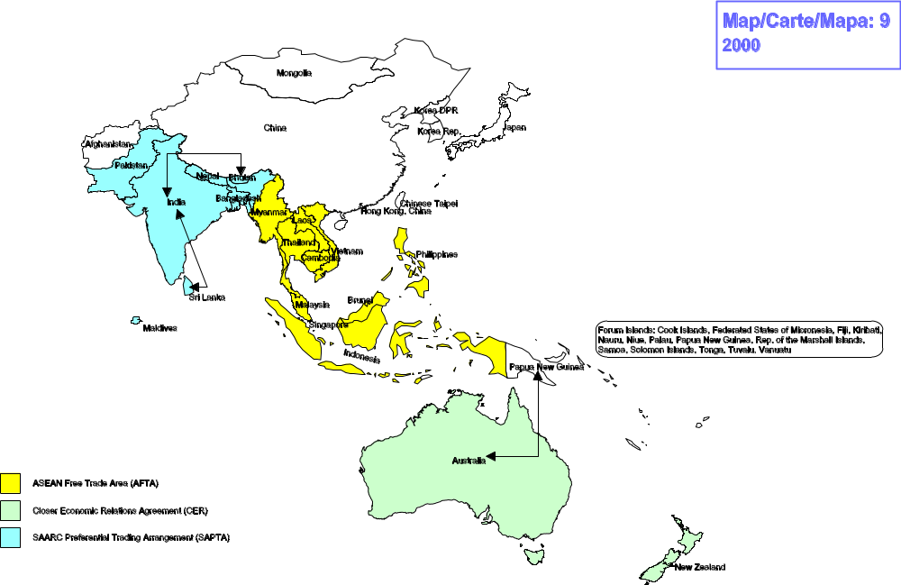
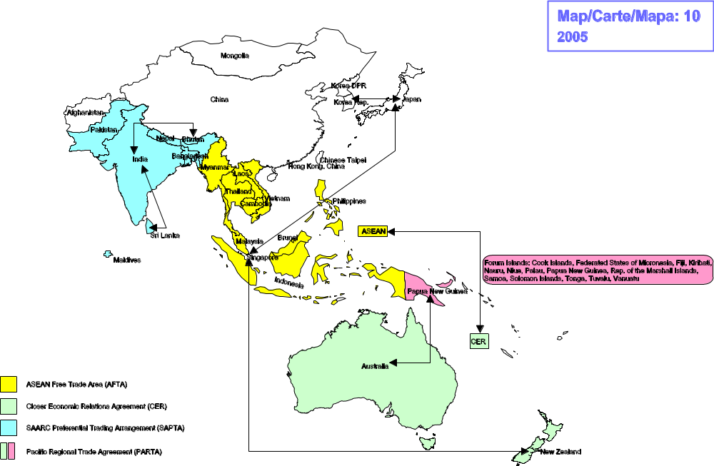
MAPS 11 – 12 Network of RTAs in force and under negotiation in the Americas
(2000/2005)

27. Map 11 shows the network of RTAs in force in July 2000 in the Americas. All countries in the region, except for Cuba, Chile, the Dominican Republic, and Panama, are currently members of one of the five main plurilateral RTAs in the region, which are the North American Free Trade Agreement (NAFTA), the Central American Common Market (CACM), the Caribbean Community (CARICOM), the Andean Community, and MERCOSUR. In addition, there are a number of bilateral agreements or agreements where one party is an RTA itself.

28. Map 12 shows the network of RTAs expected to be in force by 2005 in the Americas. By 2005, almost 20 more RTAs will have been concluded, which might at first sight seem to increase the complexity of the network of RTAs in the region. In fact, this busy phase is likely to lead to a partial consolidation, whereby some of the above-mentioned five main RTAs will have concluded free trade agreements either with each other or in some cases with individual countries. For example, the Andean Community's agreements with Argentina and Brazil are likely to have been superseded by its agreement with MERCOSUR and at least some of Chile's bilateral RTAs will have been superseded through its membership in MERCOSUR. Also all CACM members will have concluded separate agreements with Mexico to finalize the CACM-Mexico FTA. Moreover, the number of cross-regional agreements involving countries or RTAs from this region will have increased significantly by 2005 (see map 14).

29. An alternative scenario may occur after the entry into force of the Free Trade Area of the Americas (FTAA), which would cover 34 countries. It is yet to be seen what impact such an arrangement might have on the existing five plurilateral agreements in the Americas.

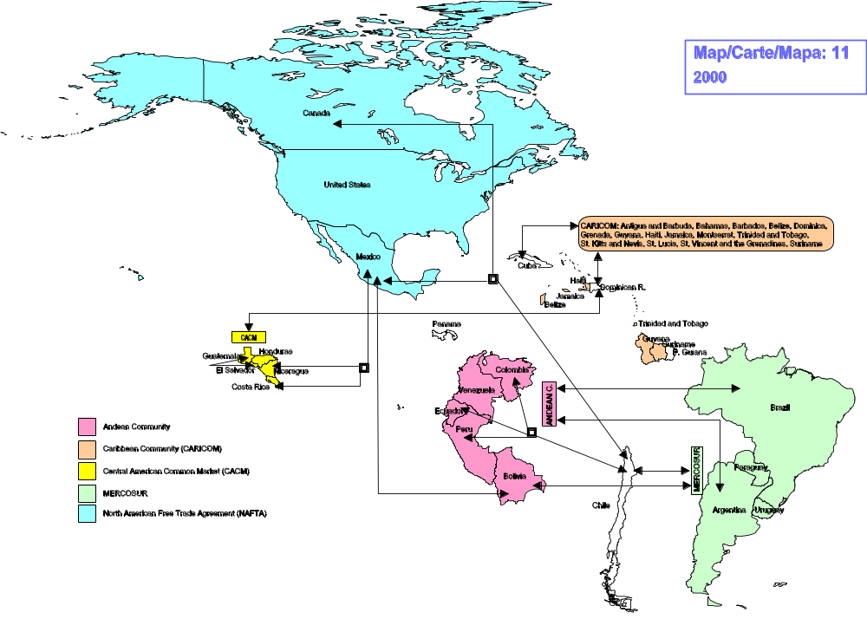
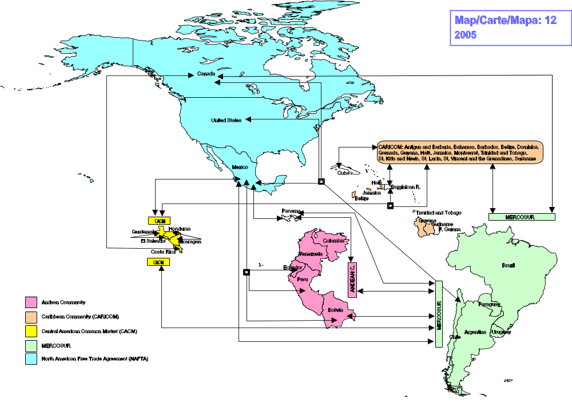
MAPS 13 - 14 Network of Cross-Regional RTAs in force and under negotiation
(2000/2005)

30. Map 13 shows the network of cross-regional agreements in force as of July 2000. Currently, Israel has FTAs with Canada, Mexico, and the United States, while the EC has RTAs with Mexico and South Africa.

31. Map 14 shows the network of cross-regional agreements expected to be in force in 2005. As can easily be seen by comparing maps 13 and 14, there is a strong trend towards concluding cross-regional agreements, some of which are being negotiated by distinct RTAs, e.g. EC-MERCOSUR, MERCOSUR-SACU. Some countries from the Asia Pacific region, which so far have not concluded any bilateral agreements, such as Japan, Korea, and Singapore are simultaneously negotiating regional and cross-regional trade agreements.
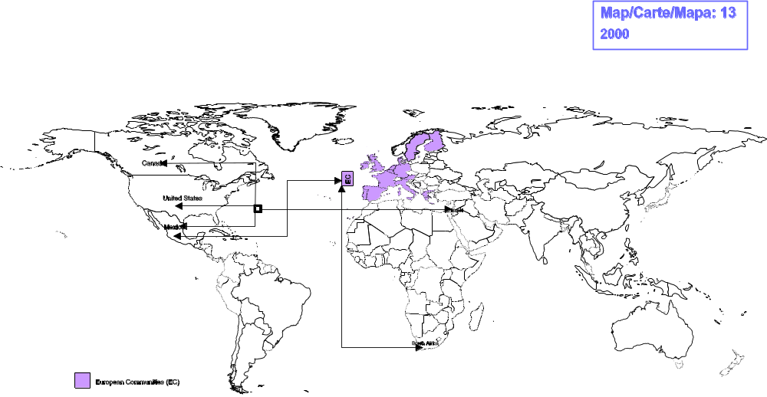
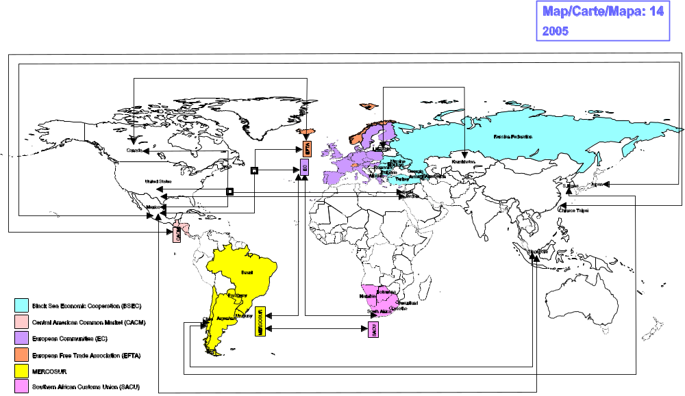
MAPS 15-16 Density Maps (2000/2005)

32. Map 15 shows the level of involvement of individual countries and customs territories in RTAs in the year 2000. It gives an indication of the total number of agreements each is involved in through the use of six different colours for six ranges of numbers. Such a map allows for a quick comparison of different countries and regions. As has already been demonstrated in earlier maps, while some countries are not involved in any RTAs, others are signatories to more than a dozen. However, it has to be borne in mind that the total number of agreements was determined without an assessment of their depth, coverage, or extent of implementation.

33. Map 16, building on Map 15, shows the expected level of involvement of individual countries/customs territories in RTAs in 2005. A comparison with map 15 shows that a significant number of countries are likely to be involved in more RTAs by 2005. This trend is most evident in the Americas and in Eastern Europe and Central Asia and also partly in the Euro-Mediterranean Region. By contrast, countries in Sub-Saharan Africa are not expected to conclude new regional RTAs, but to focus on the implementation, consolidation, and/or extension of existing ones.

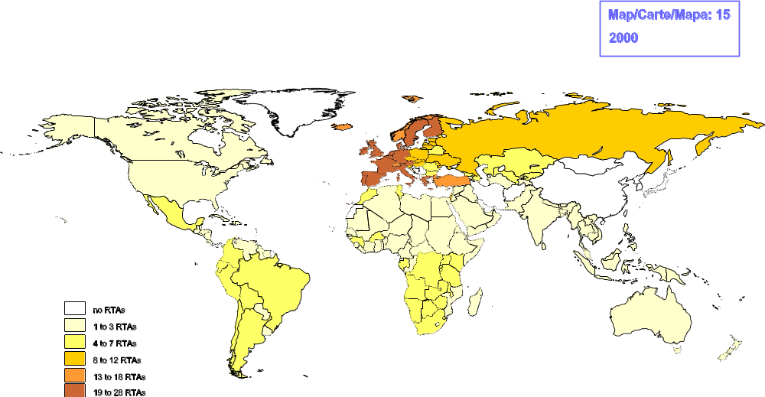
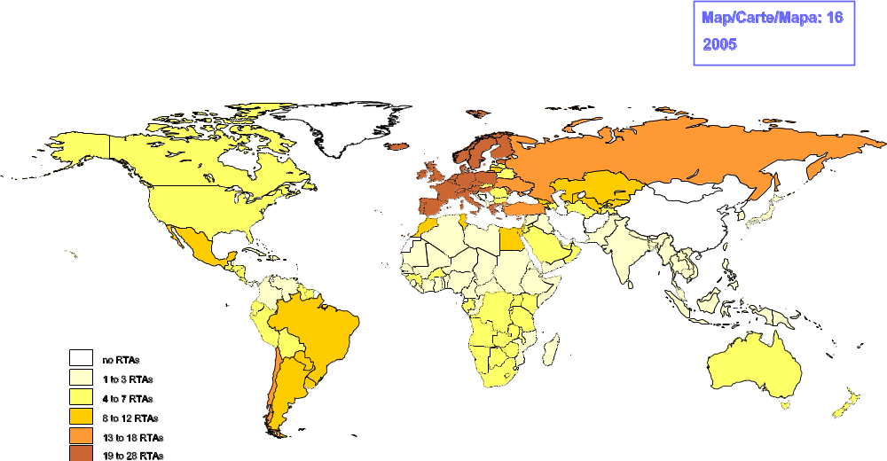
ANNEX 1

List of Abbreviations of RTAs

AFTA Arab Free Trade Area
AMU Arab Maghreb Union
ASEAN Association of South East Asian Nations
BAFTA Baltic Free Trade Area
CACM Central American Common Market
CARICOM Caribbean Community
CBI Cross Border Initiative
CEFTA Central European Free Trade Agreement
CEMAC Central African Economic and Monetary Union
CER Closer Economic Relations Agreement
COMESA Common Market for Eastern and Southern Africa
EAC East African Cooperation
EC European Communities
ECCAS Economic Community of Central African States
ECOWAS Economic Community of Western African States
EFTA European Free Trade Association
FTAA Free Trade Area of the Americas
GCC Gulf Cooperation Council
LAIA Latin American Integration Association
MRU Mano River Union
NAFTA North American Free Trade Agreement
PARTA Pacific Regional Trade Agreement
SAARC South Asian Association for Regional Cooperation
SACU Southern African Customs Union
SADC Southern African Development Community
WAEMU West African Economic and Monetary Union
__________

A direct comparison between this and the earlier note is not possible because the scope of RTAs in this note is broader (see "Definition and methods" below).
Some RTAs cover trade in goods only; others cover trade in both goods and services. No distinction is made here.
A list of abbreviations of RTAs can be found in Annex 1.
For example, press clippings, web sites, publications of other organizations (e.g., UNCTAD, IMF).
This study includes RTAs which have been notified to the GATT/WTO as well as those which have not (or not yet) been notified, without any distinction. No judgement as to the consistency of the agreements vis-à-vis WTO rules, or of their implications for the WTO system, have been considered here: such issues are being taken up under the relevant part of the CRTA's agenda.
Comments from Members on any aspect of this paper are welcome.
? No attempt is made in this document to quantify or qualify what is meant by "a large spectrum" of the parties' trade in goods.
For instance, the RTAs which were signed by the European Communities (EC) and the North African and Middle Eastern countries in the 1970s are excluded as the concessions offered by the EC were non-reciprocal. On the other hand, the new wave of EC-Mediterranean agreements (negotiated under the framework of the Barcelona Declaration) are included, as they contain concessions made by both sides.
For instance, some agreements notified to the GATT/WTO under the Enabling Clause are not included, given that they are only partial in scope.
Groups of countries and territories are not strictly chosen from a continental geographic view, but rather reflect regional clusters of RTAs. Designations of countries or territories should not be regarded as expressing an official view of the WTO Secretariat regarding their boundaries or legal status.
For example, the EC-Gulf Cooperation Council (GCC), EC-MERCOSUR, MERCOSUR-Southern African Customs Union (SACU).
For instance, this occurs when a single RTA replaces a series of bilateral agreements which have been signed over a period of time between a single country and the parties to a customs union. An example is the FTA between Mexico and the Central American Common Market (CACM), which will replace the previous bilateral agreements signed between Mexico and the individual members of the CACM.
For example, when Austria, Finland and Sweden joined the EC in 1995, they automatically became party to the EC's existing network of agreements. At the same time, the three acceding countries gave up membership in any RTAs to which they were party, e.g., EFTA, Finland-Estonia.
RTAs signed between Sub-Saharan and North African countries are considered as cross-regional RTAs in this paper.
However, some of the RTAs in force are either being renegotiated or are carrying out negotiations on various aspects.
SACU-MERCOSUR.
Examples include the RTAs signed between the EC and EFTA, as well as those signed by CARICOM and the CACM with third parties.
Examples include EC-MERCOSUR and Closer Economic Relations (CER)-Association of South East Asian Nations (ASEAN).
On the maps, country and territory names, as well as abbreviations of RTAs are shown in English only.
There is some overlap of maps, especially in the Euro-Mediterranean region and between North and Sub-Saharan Africa.
Where the maps are difficult to interpret due to size or space constraints, footnotes have been added.
For best results, the maps should be printed using a colour printer.
Other RTAs in force in the Euro-Mediterranean region (which do not involve the EC or EFTA) are shown in Maps 3 and 5.
? The EC's and EFTA's RTAs with the Palestinian Authority are not shown. The Faroe Islands are a self-governing part of Denmark, but not part of the EC.
The FTA between the EC and Switzerland also covers Liechtenstein. The FTAs between the EC and Norway, Iceland and Liechtenstein are complemented by the European Economic Area (EEA).
Other RTAs expected to be in force by 2005 in the Euro-Mediterranean region (which do not involve the EC or EFTA) are shown in Maps 4 and 6.
The EC's and EFTA's RTAs with the Palestinian Authority are not shown. Only the EC (not EFTA) has RTAs with Andorra and San Marino. Both the EC and EFTA have RTAs with Malta. The Faroe Islands are a self-governing part of Denmark, but not part of the EC. Assumes the enlargement of the EC to include Cyprus, the Czech Republic, Estonia, Hungary, Poland, and Slovenia.
The customs union between Israel and the Palestinian Authority is not shown.
For example, the Czech Republic, the Slovak Republic, Hungary and Slovenia all have RTAs with the three Baltic states, Poland has RTAs with Latvia and Lithuania only, while Romania and Bulgaria do not have RTAs with the three Baltic countries.
? The RTAs between Israel and the Palestinian Authority, and Turkey and the Palestinian Authority are not shown. Assumes the enlargement of the EC to include Cyprus, the Czech Republic, Estonia, Hungary, Poland, and Slovenia and subsequent dissolution of these six countries' bilateral networks. Does not show the six acceding countries' new network of RTAs.
? The customs union between Israel and the Palestinian Authority is not shown. The Palestinian Authority is a member of AFTA.
Relationships between countries in this sub-region and the EC and EFTA are shown in Maps 1 and 2.
? The RTAs between Israel and the Palestinian Authority, and Turkey and the Palestinian Authority are not shown. The Palestinian Authority is a member of AFTA.
? Rwanda and Burundi are members of the CBI, ECCAS and COMESA.
Shown in its entirety in maps 5 and 6.
Map does not show real size of the Maldives.
Cross-regional agreements under negotiation can be seen in Map 14.
Chile and Bolivia are associate members of MERCOSUR.
Assumes the enlargement of MERCOSUR to include Chile.
Although it is a member of CARICOM, Montserrat is not a participant in the FTAA.
? The RTA between the Palestinian Authority and the United States is not shown. RTAs between North and Sub-Saharan African countries are shown on map 7, between North African, Sub-Saharan and Middle East countries on map 5, and between Eastern European and Baltic countries on map 3.
? The RTAs between the Palestinian Authority and the United States, and the Palestinian Authority and Canada are not shown. RTAs between North and Sub-Saharan African countries are shown on map 7, between North African, Sub-Saharan and Middle East countries on map 6, and between Eastern European and Baltic countries on map 4. Assumes the enlargement of MERCOSUR to include Chile and the enlargement of the EC to include Cyprus, the Czech Republic, Estonia, Hungary, Poland and Slovenia.
While 38 per cent of countries are currently involved in more than three RTAs, that percentage will rise to 59 per cent in 2005.

