JOINT-WTO-WORLD BANK SYMPOSIUM ON
MOVEMENT OF PERSONS (MODE 4) UNDER GATS

WTO, Geneva 11-12 April 2002

International Trade and Migration of Health Workforce:

Experienced from Thailand

Dr.Suwit Wibulpolparsert
Deputy Permanent Secretary
Ministry of Public Health, Thailand

- External Brain Drain

  - The event: Develop countries occasionally open their health workforce market in respond to increasing internal demand. In the decade of 1960’s, Vietnam War and the Medicaid and Medicare system had greatly increased demand for health workforce in the USA. The US government temporarily open its health workforce market and big migration from developing countries occurred. This is a great loss for the poor countries as medical doctors are usually their best brains and are trained with high public subsidization. In Thailand, almost but one Thai medical schools are public. The medical students shoulder less than 5% of the cost of training. Thailand lost more than 1,500 doctors, mainly to the USA, during that decade. Between 1963-1965, more than one-third of new Thai medical graduates flew to the USA (Table 1). Very few of these migrants return home. Thus it is a permanent loss.
This event of external brain drain has nothing to do with any bilateral or multilateral trade agreements. It occurs mainly from market opening, demand for continuing education, opportunity for career development, and better living standard.

Table 1 Migration of M.D., Thailand

Year | Emigrants | Total graduates | % external brain drain
1963 | 56 | 233 | 24.03
1964 | 81 | 236 | 34.32
1965 | 140 | 276 | 51.72
Total | 277 | 745 | 37.18

Source: Human Resource for Health Development Journal, 1999:1; p.4.

  - Government measures: The Thai government initiated some measures since late ‘60s to alleviate external brain drains.
- Compulsory Public Work: Medical students have to sign contracts with the public universities that they will serve the public for 3 years after graduation. In case they breach the contract, there will be a fine of USD 12,000. At least two-third of the contracted new graduates is dispatched to rural district hospitals. Health facilities in the rural areas, particularly rural district hospitals, were also greatly developed late early 1970’s. In 2000, they cover more than 90% of all rural districts. They are well equipped with modern facilities and trained staff.
- Increase supply: Increase production of doctors through a system of rural recruitment and hometown placement was initiated since 1974 (Figure 1, 2).
- Incountry specialty training: Specialty training program for medical doctors was started by the Thai Medical Council since 1971. There are now 45 specialties and more than 55% of Thai doctors are Thai board certified specialist (Figure 3).
- Increase allowance in addition to basic salary. Hardship allowance was started since 1972. Many more financial incentives were later added on (Table 2).
- Career development and social recognition. Directors of rural district hospital are equivalent to the level of director of a division or a deputy DG. Some annual awards one given to best rural doctors.

Figure 1 Annual output of medical doctors
Number

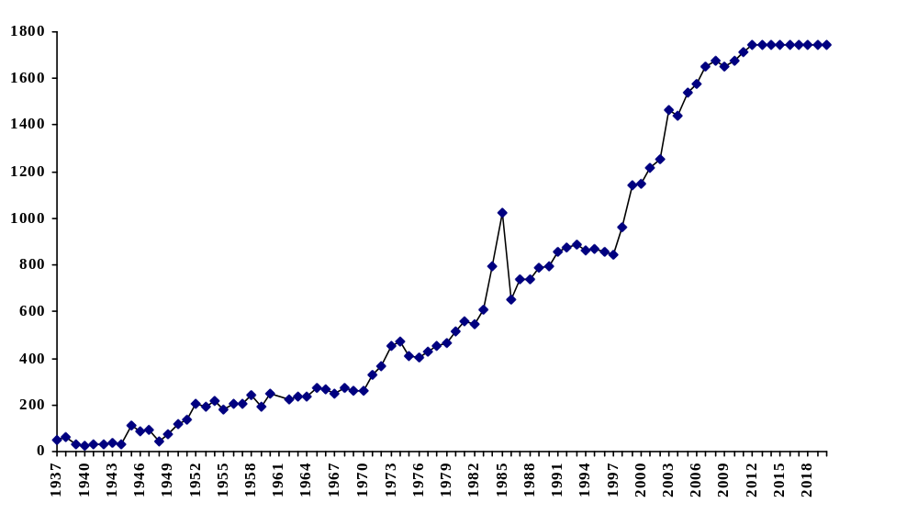 Source : Thai Medical Council

Year
Rapid economic
growth
CPIRD (+300/yr)
Increase production (+340/yr)
Compulsory
public work
External brain drain
CPIRD = Collaborative Project to Increase Production of Rural Doctors.

Figure 2 Proportion of rural medical students
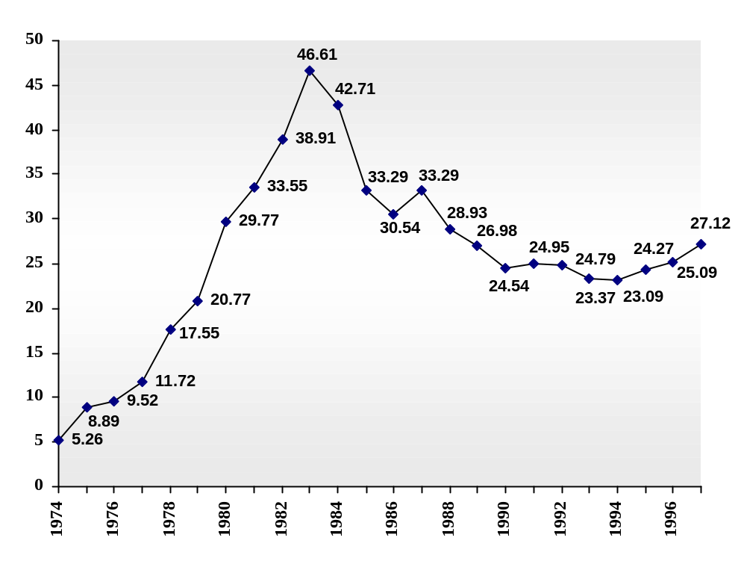
%
Year
CPIRD
CPIRD = Collaborative Project to Increase Production of Rural Doctors.
Source : Faculty of Medicine of all universities.

Figure 3 Proportion of medical specialists and general Practitioners, 1971-1999

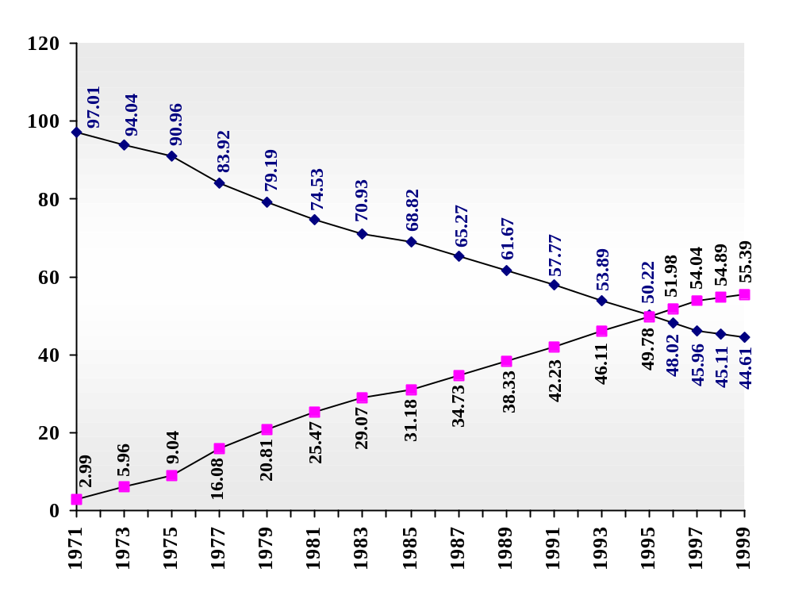
%
Year
Source: Thai Medical Council

Table 2 Monthly remuneration of MoPH doctors working in rural hospitals in 2000 ($US)

MoPH doctors working  in rural hospitals | Monthly remuneration  (US$)
- Salary (new graduates)  - Non private practice  - On-call services  - Special procedures  - Special clinics  - Hardship allowance | 200  250  250-300  70-130  100-300  50-500
Total | 920-1,680

  - Implications: The situation of external brain drain improved greatly since mid ‘70s. There was no systematic study on the effectiveness of the government measures. However, the end of the Vietnam War had greatly reduced the demand in the USA, and the door to the health workforce was greatly narrowed during the same period.
The rapid economic growth during late ‘80s to mid ‘90s with increase ability to pay support rapid growth of the private hospitals. These further reduce the external migration.

- Internal Brain Drain

  - There is always a big gap between health workforce density in the poor rural areas and the richer urban cities. In 1979, the doctor density in Bangkok was 21 times that of the poorest northeastern region. The government measures mentioned in 1.2 greatly reduce this gap down to 8.6 times in 1987 (Figure 4).

Figure 4 Inequitable distribution of doctors (1977-2001)
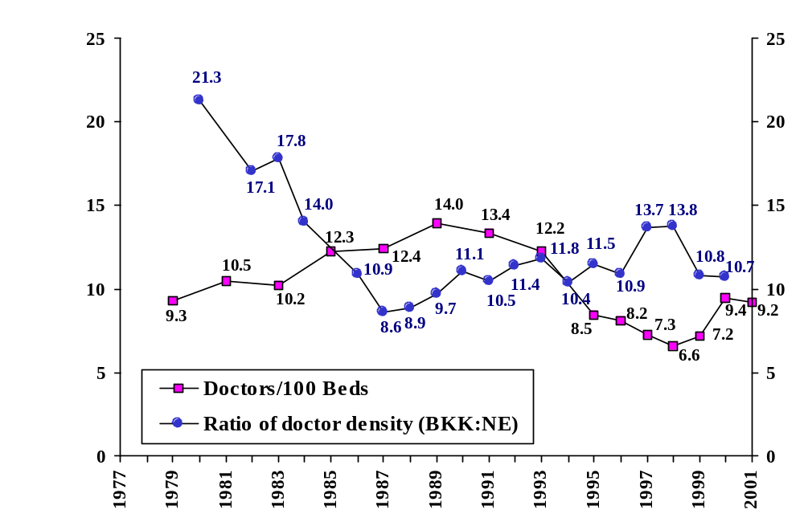
Doctors/100 bed
Ratio of doctors density
Year
Econ. crisis
Econ. boom
BIBF
  - Rapid economic growths during late ‘80s to mid ‘90s with mushrooming of private hospitals reverse this trend.
The opening of the financial market in 1992 with rapid influx of low interest loans further enhanced the over growth of private hospitals (Figure 5). There is almost 300 percent over supply of private hospital beds. This situation resulted in severe internal brain drain and the doctor density gap once again rose to 14 times in 1997 (Figure 4). In April 1997, a few months before the economic crisis, 21 rural district hospitals went on without single full time medical doctors!

Figure 5 Private doctors and beds in Thailand (1970-2000)

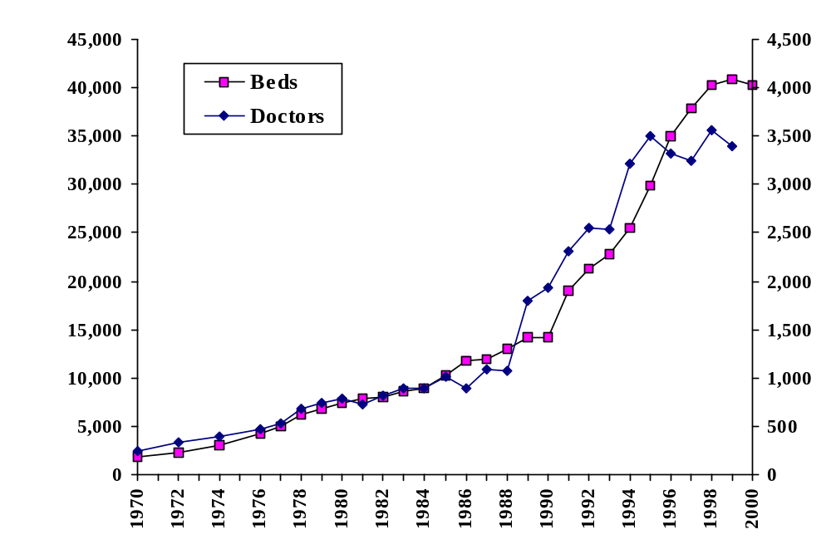
Beds
Doctors
Year
FDI
Econ. boom
BIBF
BIBF = Bangkok International Banking Facility (opening of financial market)
FDI = Foreign Direct Investment
Source: Thailand Health Profile, 1999-2000.

  - Economic crisis in 1997 resulted in bankruptcy and downsizing of many private hospitals. Internal brain drain was totally disappeared. The trend of doctor migration was reversed, and the gap went down again to 10.7 times in 2000 (Figure 4).

- Conclusion

  - External brain drain can occur unrelated to any bilateral or multilateral trade agreements. Before commitment to GATS, opening of health workforce market depends on decision by each (develop) countries. If there is enough supply, the country can then close its door to foreign practitioners. The external brain drain may then reduced.
With the commitment to GATS mode 4, once the market is opened, it is difficult to close. Thus if developed country commit to GATS mode 4, and permanently open its health workforce market, the external brain drain may be continuous and sustained.
However, apart from barriers, which may be removed by GATS mode 4, there are other socio-cultural barriers such as languages (Figure 6). Not very many Thai nurses migrate out of the country; one reason is their limitation in English proficiency.

Figure 6 Barrier to Mode 4 for health professionals

Entry VISA
Work Permit
License – practice/premise
Investments permit

Finance - Insurance/Self
Socio – Cultural*
Effectiveness*

* GATS can not reduce these barriers

  - In addition to GATS mode 4, particularly in the business sector (which includes health professionals), commitment in other sectors and modes of trade can greatly influence the migration of health workforce. The internal brain drain in Thailand, which related to opening of financial market, is one good example. Promotion of health tourism and GATS mode 2 in health service sector will revitalise the bankrupted private hospitals and recreate the situation of internal brain drain. Investment in private hospitals in other developing countries by Thai and foreign investors may also attract well train Thai doctors to work abroad. Thus we may need to be more holistic in our analysis.

  - Multiple integrated and holistic strategies implemented seriously and concertedly are needed to alleviate the problem of health workforce migration.

