World Trade
Organization
World Trade  Organization | G/TBT/GEN/123/Rev.1  4 November 2011
 | (11-5604)
Committee on Technical Barriers to Trade

workshop on regulatory cooperation between members

8-9 November 2011

Programme

Revision

At the November 2010 meeting of the TBT Committee, delegations agreed to hold a Workshop on Regulatory Cooperation between Members. This Workshop will be held on 8-9 November 2011 back to back with the TBT Committee's regular meeting on 10-11 November. The discussions will be held in panel sessions and will focus on the topics set forth in the attached programme. Members, including relevant interested parties of their delegations, as well as observers are invited to participate in this Workshop. Background information on the topic of regulatory cooperation between is contained in document G/TBT/W/340.

It is stressed that all Members should communicate the names of their capital-based participants, by fax or e-mail. These names should be sent to Mrs. Una Flanagan (e-mail: una.flanagan@wto.org, Fax: +41 22 739 5620) with a copy to: bci@wto.org.

Please note the Workshop will take place at the CICG. The entrance to the builing is on Rue de Varambé. A map is annexed to this programme.

_______________

8-9 november 2011
Registration* (08h00 – 9h20)

10h00 Opening Remarks

Chairperson of the TBT Committee, Ms Denise Pereira

Session 1: Overview of Regulatory Cooperation

Moderator: Ms Denise Pereira
            - WTO: "Background of the TBT Committee's work on Regulatory Cooperation"
Mr. Erik Wijkström
            - WTO: "The experience of the SPS Committee in developing and implementing guidelines on equivalence" Mrs. Marième Fall de Perez Rubín

Session 2: Members' Experiences

Moderator: Mr. George Opiyo (Uganda)
            - China - EU Cooperation (joint presentation): Working Together to Make Consumer Products Safer: the China-EU example, Mr. Kong Xiao Bang (China) and Mr. Fabrizio Sacchetti (EU)
            - EU – US Cooperation (joint presentation): Mr. Jan Eric Frydman (EU) and Mr. Jeff Weiss (US)
            - New Zealand – Australia Cooperation (joint presentation): "The trans-Tasman Experience with regulatory cooperation", Ms Sirma Karapeeva (New Zealand)
            - Brazil: "Strengthening International Cooperation to Improve Regulation in Brazil: Pro-Reg and Regulatory Guidance", Mr. Rodrigo Augusto Rodrigues and Mr. Alfredo Lobo.
            - Mexico: "The Mexican experience with regard to Regulatory Cooperation: challenges and benefits", Mr. Juan Antonio Dorantes.

Session 3: Cooperation in Other Fora

Moderator: Mr. Bipin Menon (India)
            - APEC: "Regulatory Cooperation in APEC", Ms Sirma Karapeeva (New Zealand)
            - APEC: "Mutual recognition arrangement on conformity assessment of electrical and electronic equipment: its implications in reducing Technical Barriers to Trade", Ms Carolina Vasquez (Chile)
            - ASEAN: "Experience of the ASEAN Consultative Committee on Standards and Quality (ACCSQ)" Mr. Ho Chi Bao (Singapore)
            - SARSO (South Asia Regional Standards Organization): Mr. Chandan Bahl (India)
            - OECD: "The challenge of sharing information – Obstacles and cooperation mechanisms in the field of product safety", Mr. Peter Avery (OECD)
            - UNECE: "A common regulatory language for trade and development: the case of the International Model and Harmonization of Vehicle Regulations", Mr. Christer Arvius (UNECE)

Session 4: Panel on Lessons Learned
Moderator: Mr. Matthew Smith (Canada)
            - Mr. Bipin Menon (India)
            - Mr. George Opiyo (Uganda)
            - Mr. Rodrigo de Macedo Pinto (Brazil)
            - Mr. Jeff Weiss (United States)
            - Mr. Jan Eric Frydman (EU)
            - Mr. Xinhua Sun (China)

_______________

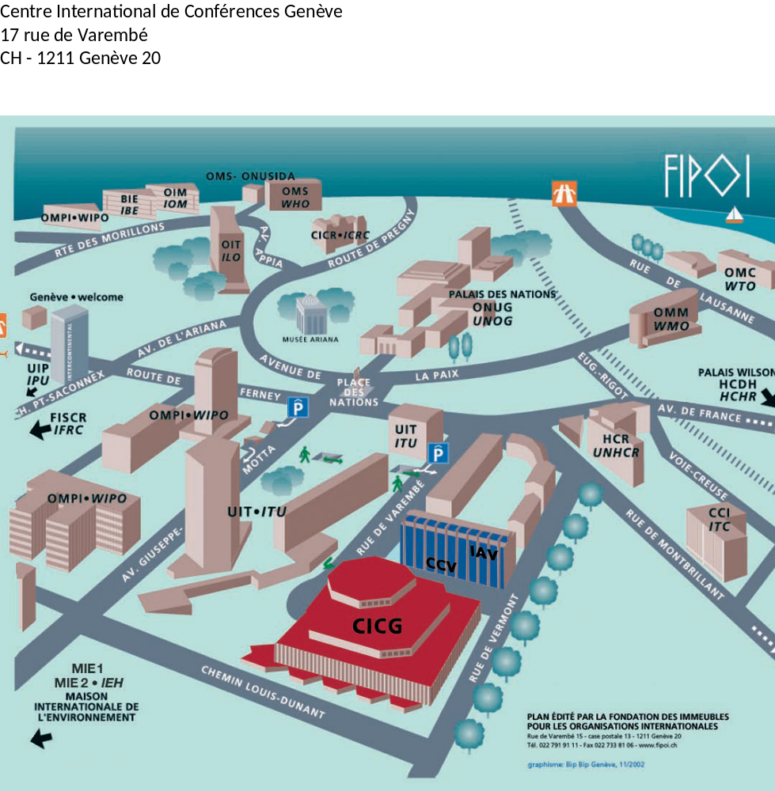

__________

* Registration will take place at the WTO building (Centre William Rappard)

